North Luffenham

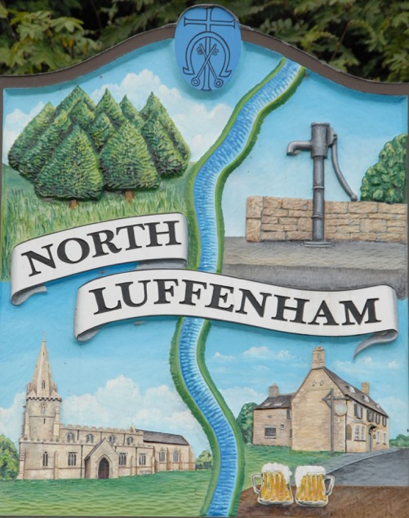

The village of North Luffenham is situated on high ground north of the River Chater, but the Parish extends across the river to the Settings and eastwards to the Ketton Road, where there are a few outlying houses. In the Parish there are about 340 houses.

The following contains some useful information but much more detailed information is available on the village website, www.northluffenham.com and if you sign up to the website you will be kept up to date with village news and events.

USEFUL TELEPHONE NUMBERS

Emergency Services: Fire/Police/Ambulance | 999 or 112
Police | 101 is now the number to call when you want to contact your local Police - when it's less urgent than 999
Fire Brigade | 0116 287 2241 for enquires
NHS Out of Hours | 111 If you need medical help fast but is not emergency.
Electricity | Western Power Distribution - 0800 056 8090. Mob- 0330 123 5009
Gas | Emergencies – 0800 111 999
Water Supply-  Fresh Water | Severn Trent emergencies – 0800 783 4444
Sewerage | Anglian Water emergencies – 08457 145145
Hospitals | Stamford & Rutland Hospital – 01780 764151
 | Rutland Memorial, Oakham – 01572 722552
 | Peterborough City Hospital - 01733 678000
 | Leicester Royal Infirmary – 0300 303 1573
 | Glenfield General Hospital - 0300 303 1573
 | NHS Direct – 0845 46 47
Hospital A&E | Peterborough City Hospital – 24 Hrs
 | Leicester Royal Infirmary – 24 Hrs
 | Stamford & Rutland Hospital – Minor Injuries; not 24 Hrs (9am – 5pm)
 | Rutland Memorial, Oakham – Minor Injuries; not 24 Hrs (9am – 5pm)

Local Doctors Surgery

Two rural practices serve the village:

Empingham Medical Centre: 01780 460202
The Uppingham Practice: 01572 823531

Parish Council:

Parish Council meetings are held in the Community Centre and notices of meetings are placed on the village notice boards prior to the meetings, and also on the village website, www.northluffenham.com. The minutes of Parish Council meetings are also posted on the village website. Parishioners are welcome to attend these meetings, which are always preceded with a public forum, when parishioners may raise any parish matters with the Council.

Parish Councillors:

Paul Cummings (Chairman) 01780 720124
Charles Cade (Vice-Chairman) | 01780 720467
Pete Burrows | 01780 721674
Steve Marson | 01780 721803
Claudia Riordan | 01780 721211
Tim Smith | 01780 360083
John Sewell | 07747 085381
Gina Inman | 01780 720420
Parish Clerk – Angela Ashpole | 01780 729406

The Parliamentary Constituency is “Rutland and Melton” and the
MP is the Rt Hon Alan Duncan, Conservative. alan.duncan.mp@parliament.uk

County Councillors for the Normanton Ward: Gale Waller and
Kenneth Bool.

Rutland County Council offices are at Catmose, Oakham –
01572 722577 www.rutland.gov.uk.

Churches:

The Parish Church of St John the Baptist is one of the group of 10 Churches that make up the Rutland Water Benefice in the Diocese of Peterborough. All the services are published in a monthly Parish Magazine that is delivered to every house in the village and at www.rutlandwaterbenefice.info

The main Methodist Church is at Barn Hill, Stamford.

The Catholic Parish of Rutland: The main services are at St Joseph, Oakham. There is also a mass on Sundays at 9.00am at St Thomas of Canterbury, Exton. Once a month, at noon, there is a mass on Sunday at Uppingham School Chapel.

Trades and Services:

Public House: | “The Fox” situated on Pinfold Lane 01780 720991
Post Offices with village shop: | Situated in Edith Weston and Ketton.
Refuse collection: | Tuesdays - Alternate weeks Black and Green then  Grey.
Market Days: | Stamford: Friday and Saturday  Oakham: Wednesday and Saturday  Uppingham: Friday
Mobile Vans: | Nelsons Butchers on Saturday mornings.  Arthur’s Fish & Chip Van on Friday around 7.30pm  Outside The Fox.
Library Services: | A mobile service visits the village: for place  and times go towww.rutland.gov.uk

The Parish Magazine contains advertisements for various local businesses and is delivered to each household monthly.

Schools

The Church of England St. Mary and St. John Primary School in
North Luffenham serves a number of villages. The Headmistress is
Mrs. Fiona Wilce. Tel: 01780 720184.

Uppingham Community College: 01572 823631 www.uppinghamcollege.org.uk provides secondary education
although there are also two other colleges in the area.

Catmose College: 01572 770060 www.catmosecollege.com in
Oakham.

Casterton Business and Enterprise College: 01780 762168 www.rutlandcountycollege.com . in Great Casterton.

Rutland County College: for 16 – 18 year olds. 01572 722863
www.rutlandcountycollege.com

There are also Public Schools in Oakham, Stamford and
Uppingham.

Community Centre

The Community Centre is sited within the primary school in which there is a community wing that is used by a number of groups during the week. Community groups, out of school hours, may use other parts of the school, particularly the hall. For further information on hiring the Community Centre contact Janet Whittaker on 01780 721216 or the School Secretary who administers the diary on 01780 720184.

Recreation Facilities:

The area in the centre of the village is known as the Oval and is looked after by the Parish Council on behalf of the village. Rules for use are on the Parish Notice Boards. Bookings are made through the Parish Clerk. There are a number of items of children’s play equipment, a basketball court and football nets available for use.
The village cricket team uses the Oval for their matches. They
have a pavilion and practice nets.
For further information: www.nluffenham.play-cricket.com.

Good Neighbour Scheme:

This Scheme is a coordinated network of local volunteers who provide informal help and support to residents within the community who need a little extra help with household tasks or short essential trips out. A leaflet and fridge magnet is enclosed.
More information is available on the village website.
Telephone 07825 697841 for assistance.

Defibrillator:

A defibrillator is located at “The Fox” Pub. Call 999 first then call 01780 322070 for assistance. An explanatory leaflet and a fridge magnet are enclosed.

Allotments:
A number of allotments are available on Pinfold Lane. Allocation and waiting list information is available from Charles Cade 01780 720467.

Local Papers:
The ‘Stamford & Rutland Mercury’ and the ‘Rutland Times’ are published weekly.

Village Societies / Clubs and Activities in the area

The village website is www.northluffenham.com and you can subscribe to the village website and receive updates when new posts are made
On the website there is a heading ‘Clubs and Societies’ and contains all the relevant and up to date information as well as contact details..

Art Group: | Meet on two Mondays in the month in the  Community Centre.
Bowls: | The Chater Bowls Club on Pinfold Lane.
Camera Club: | Meet on 3rd Tuesday five times a year – January, March, May, September and November at 8.00pm in the Community Centre.
Chater Community Choir: | Meet Tuesdays 7.30 – 9.00pm usually in term time at Edith Weston School
Cricket: | New members always welcome.  Contact Kevin Corby 0797919205671
Cycling: | There is good road cycling in the surrounding lanes that are fairly quiet with traffic. Off road cycling for the family is available in Fineshade Woods and more demanding trails in Wakerley Woods.  There is a cycle trail all the way around Rutland  Water. www.anglianwater.co.uk/leisure  Bike Hire at Rutland Water: Whitwell and  Normanton. Also at Fineshade Woods.
Fishing: | Rutland Water by permit from the Anglian Water Authority at Normanton Fishing Lodge. Rutland Water is a fly only reservoir and holds both brown and rainbow trout. Bank fishing or boats are available to hire for part day or all day. There is a well stocked fishing shop on site for advice and equipment. Open season April to November.  Lessons are also available and booked via the shop. 01780 686441. www.anglianwater.co.uk/leisure
Garden Club: | Meets normally 2nd Thursday each month, 7:30 pm at the Community Centre.  Contact Katy Ellis 01780 722173
Golf Society: | For the various events and contact details: see  North Luffenham Village website.
Golf: | Luffenham Heath Golf Club, Fosters Bridge.  North Luffenham Golf Club, St Georges Barracks.  Rutland Water Golf Club, Edith Weston.
Good Companions: | Senior citizens club meets on the 4th Wed. every month in the Community Centre. Contact Evelyn Pickard 01780
Indoor Bowls: | Meets on Monday and Wednesday evenings in the Community Centre.  Contact Jason Ellis 01780 722173.
Sailing and Windsurfing: | Rutland Sailing Club at Edith Weston. 01780 720292. www.rutlandsc.co.uk  Facilities for casual sailing and windsurfing are also available at Whitwell. www.anglianwater.co.uk/leisure
Scouts, Beavers and Cubs: | Scouts: Thursdays evening.  Beavers and Cubs: Tuesday evenings.  Contact: Jane Mason 01780 721419.

