BACK BY PUBLIC DEMAND!

THIS
SUY!
The Great British Pudding Competition & Raffle

in aid of
North Luffenham Church Roof
& Save the Children Fund
SUNDAY 8th March 2015
AT 2.30PM (straight after SUNDAY LUNCH!)
AT NORTH LUFFENHAM COMMUNITY CENTRE
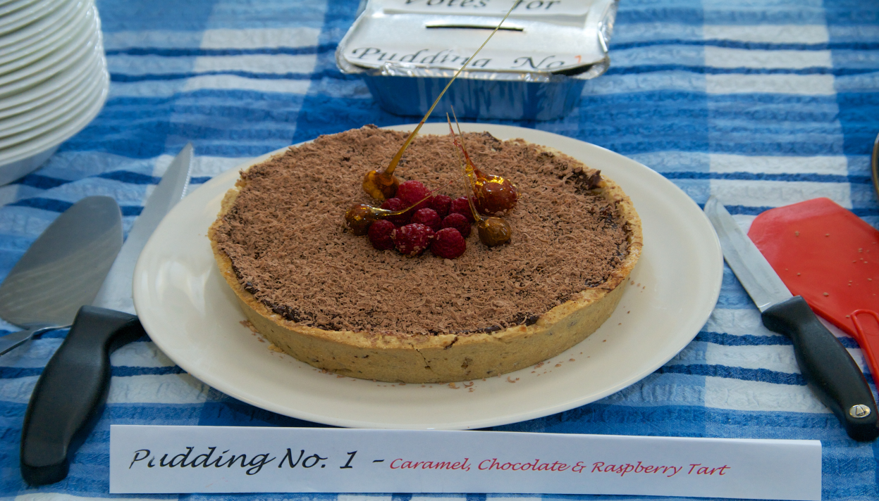
TICKETS: Adults £5 Children £2-50 which includes
all the pudding you can eat & tea/coffee & chocolate mints
Competition open to all pudding makers, young & old
Secret ballot for first three most popular puddings with prizes
Please tel: 721216 to register an interest
or just turn up on the day

