Chater Community Choir
presents

Sounds for a Summer Evening
In aid of the Brain Tumour Charity and
The Wendy Gough Cancer Awareness Foundation
Uppingham Parish Church
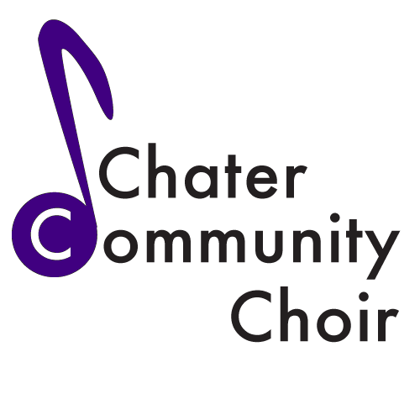
Saturday 6th June 2015
7:30pm Tickets £5
Available from Tracy Steward 01780 729006
Or Jenny Clarke 01572 821197

