30 July 2015

Parish Councillors
Parish Clerk (For Website)

NORTH LUFFENHAM PARISH COUNCIL
INFORMATION BRIEF – “THE NEIGHBOURHOOD Plan”

BACKGROUND

1. The Parish Council has identified that to enable it to make strategic decisions about the development of the village and to manage its’ day to day business and meet the aspirations of villagers, it is important that a Neighbourhood Plan be developed. The type of issues to be considered will include: environment; planning / development; transport and roads; recreational facilities; health; community issues; education; community safety; volunteers; senior citizens; youth / youth activities and any other issues considered relevant.

2. The aim of this note is to ‘sow the seed’ and to help Parish Council and villagers understand what is planned, to get people talking about the proposal and to outline how it might be achieved. We live in a beautiful place and our plan is likely to concentrate on how we can protect its character, influence any future proposed development and where appropriate enhance its facilities.

AIM

3. The aim of the Neighbourhood Plan is to find out what people think about the area they live in - what's good, what's bad and what needs to be changed or improved to make it a better place in which to live. The Neighbourhood Plan is a document that tackles important issues that will influence the Parish in the future (5 – 10 years).This could be anything from ensuring building projects fit in with local character to supporting alternatives to private car use, to improving the state of the Oval and other village amenities. The development of the plan will be led by the parish council but must take into account the views of the whole community. We believe that our Village is a great place to live and would benefit from having a plan that identifies those things must be protected or enhanced and those things, such as local transport provision, that need to be improved for the greater good of the whole community.

PURPOSE

4. Neighbourhood Plans are an important tool that can be fed into other plans and strategies such as Local Plans, where the needs of a village and its surrounding countryside might not normally be adequately considered by the County Council and other statutory bodies. It will be important to work closely with Rutland County Council planners from the outset, and an early meeting has been arranged with the Senior Planning Officer (Planning Policy). It is hoped that the County Council will adopt the plan as a Supplementary Planning Document that would carry significant weight as a material consideration in the planning decision-making process. If the plan has been subject to widespread and effective community involvement, the plan will help to inform responses to planning applications.

5. The final plan will identify key facilities and services, set out the problems that need to be tackled and show how distinctive character and features can be conserved. It will also include an action plan for the delivery of its recommendations.

CONTENT

6. We have been advised that a well-executed Neighbourhood Plan:

- reflects the views of all sections of the community
- identifies features and local characteristics that people value
- identifies local needs and opportunities
- sets out a vision of how people want their community to develop and improve
- includes an Action Plan to achieve this vision.

DEVELOPING THE NEIGHBOURHOOD PLAN

7. The first steps in preparing a plan will be to research in depth the requirements; best practice and accepted methodology and to identify the funding required to develop such a plan. This work will initially be undertaken as a Scoping Study by the Parish Council.

8. Researching, developing and writing such a plan is a major piece of work, that is likely to take a year or more to achieve. It needs to be undertaken by enthusiastic volunteers within the community and is not the sole responsibility of the Parish Council. We intend to enable everyone in the village to have a say and will actively encourage participation by all. We will be looking for volunteers to help to conduct surveys and to run focus groups, both of which will help to provide knowledge and understanding of key issues and of course to help write the plan.

9. Once the initial scoping study has been completed we will hold a public meeting in October to present what is proposed; confirm funding requirements; and to appoint a Steering Group to take the initiative forward.

CONCLUSION

10. North Luffenham Parish Council is strongly supporting the concept of a Neighbourhood Plan as a way for this rural community to express its views and aspirations and to be heard. It is anticipated that Rutland County Council will equally pledge their support. The idea will be need to be developed further through a scoping study to understand fully the benefits, scope and legal standing of such a plan.

RECOMMENDATION

11. It is recommended that the Parish Council endorse an initial Scoping Study be undertaken to be presented at the September 2015 Parish Council Meeting. The scoping study will be prepared by Cllrs Cummings and Smith and the draft report will be circulated to all Parish Council members for consideration and comment prior to publication.

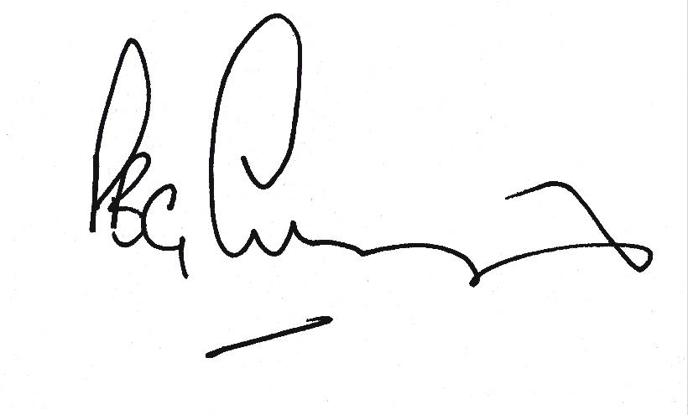
PBG Cummings
Chair NLPC

