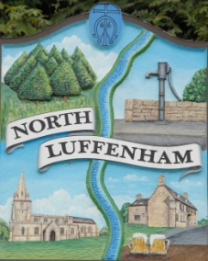
Angela Ashpole, Parish Clerk
North Luffenham Parish Council
‘Bee in Thyme’, 7 Glebe Road, North Luffenham, Rutland, LE15 8UJ
Tel 01780 729406 email: nlparishclerk@outlook.com

Oval Use Application Form
Please complete then return to the Parish Clerk either by post or email (as above) at least 14 days before the date of your event/activity so that your application can be fully considered and further questions raised if necessary. The Parish Council wants the Oval to be used and enjoyed as much as possible for the benefit of all residents, so its policy is to agree to all reasonable requests.

Details of applicant
Name:
Organisation:
Address:
Telephone:
Email:

Details of proposed activity/event
Date: Time start: Time finish:
Expected number of people:
Brief summary of the proposed activity/event:

Specific consents required
Please enter ‘No’ or provide details to each of the following 5 questions:
- Will you be bringing any animal(s) onto the Oval other than for the purpose of exercise (Regulation 4)?

- Do you anticipate that any vehicles will need to be brought onto the Oval (Regulation 5)?

- Will you be doing anything that could potentially damage the grass or ground surface (other than normal ‘wear and tear’, eg from sporting activities) (Regulation 6)?

- Do you intend to cook on a barbecue or light a fire of any nature (Regulation 7)?

- Do you wish to erect a structure of any sort on the Oval, whether permanent or temporary (Regulation 8)?

