Supporting People &
Sustaining Communities

Supporting People &
Sustaining Communities
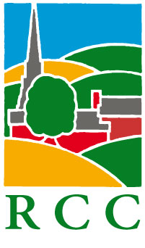

ACHIEVEMENT AWARDS 2016

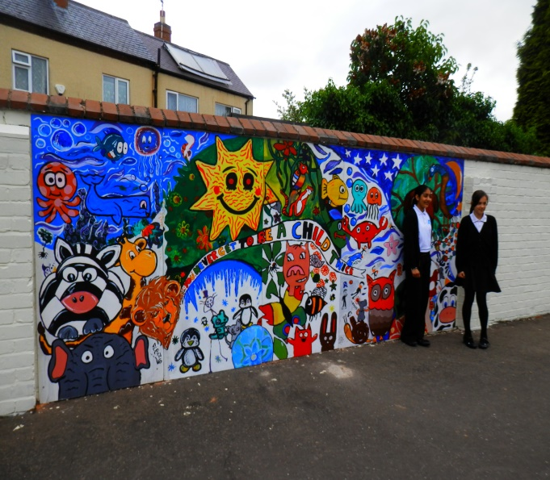
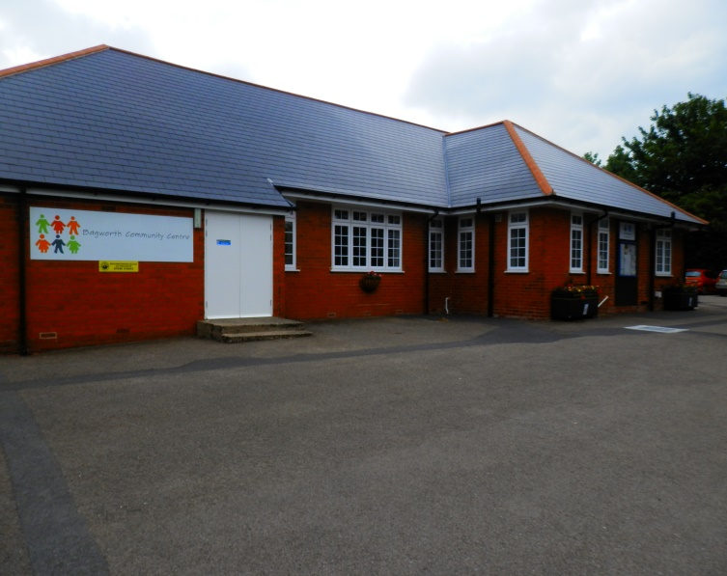

- Here is an opportunity for you to show off your community and gain recognition for what you have achieved.
- The RCC in their role of supporting People and Sustaining Rural Communities in Leicestershire & Rutland invite entries for the 2016 Achievement Awards
- The Achievement Awards are open to all communities under 15,000
- It doesn’t matter if this is your first time, or if you have entered in previous years. Tell us what you are proud of and what you do for your community
- Full details and entry forms can be downloaded from our website www.ruralcc.org.uk or contact Pat Crane on 01455 823537 or by email on patcrane33@gmail.com
......................................................................................................

RCC ACHIEVEMENT AWARDS 2016

Expression of Interest

If you would like to enter a project in this year’s Awards, please provide your details and we will send you an application pack; preferably by e mail, but hard copies can be posted or downloaded from our website

Name:........................................... Organisation:.............................................

Address:...........................................................................................................

E mail:..................................................................Phone:...................................

We look forward to hearing from you!

