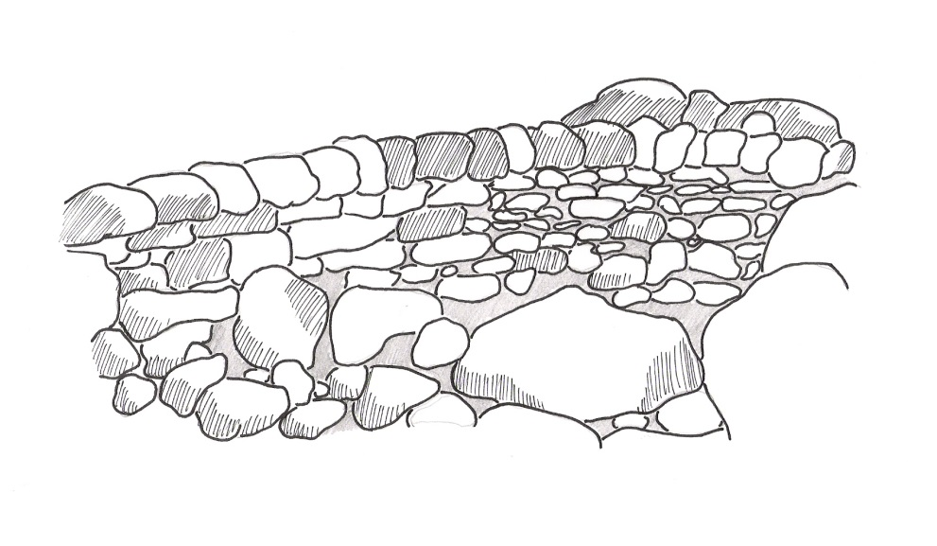
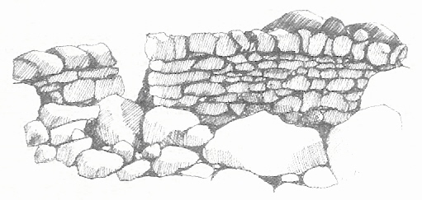
Clive Braddock

29 Reedings Road
Barrowby
Grantham
Lincs
NG32 1AU

Home: 01476 572270
Mobile: 07745 047452

22 January 2016

Mr C Cade
Chairman of North Luffenham Parish Council
4 Glebe Road
North Luffenham
Oakham
Rutland
LE15 8JU.

Dear Mr Cade,

ESTIMATE OF THE COST OF REBUILDING SEVERAL SECTIONS OF DRY STONE WALL AND OTHER WORK.

Thank you for asking me to provide an estimate of the cost of the work required to take down and rebuild several areas of dry stone wall together with the repair of mortared stone steps at The Green, North Luffenham.

For ease, I hope, of understanding, I attach a second sheet on which I have detailed the projects and the likely costs together with any relevant notes.

Please note that the costs shown may vary if you were to alter your requirements from those discussed or if works arose which are unforeseen.

I hope this is acceptable and look forward to hearing from you.

Yours sincerely,

Clive Braddock

Clive Braddock.

Professional Craftsman of the Dry Stone Walling Association and
Professional Member of the National Hedge Laying Society
Project 1: Take down approximately 19 square metres of uncapped dry stone
wall. Rebuild the length of wall to a lower height of approximately
0.8 metres and use any remaining stone to cap the wall in the
cock and hen style

- Take down and clean out the existing wall.
- Rebuild to the lower height.
- Cap with cock and hen copings.
£
Cost of labour 1970.00

Project 2: Take down and rebuild approximately 11 square metres of dry
stone wall, capped with the existing mortared coping stones.
This total area comprises several small areas.

- Take down and clean out the areas of wall.
- Rebuild.
- Mortar the existing coping stones to cap the wall.
£
Cost of labour 1379.00
Cost of materials and plant 139.00
1518.00

Project 3: Repair the mortared stone step.

- Remove the blown stones.
- Replace the stones using a lime mortar.
£
Cost of labour 197.00
Cost of materials and plant 50.00
247.00

Notes:

- I have assumed that the stone which is on site is sound.
- If you require any new stone, I am able to provide it at an additional cost.
- The cost of disposal of the spoil is not included in the above price. If you wish me to dispose of it there would be an additional charge.

Professional Craftsman of the Dry Stone Walling Association and
Professional Member of the National Hedge Laying Society

