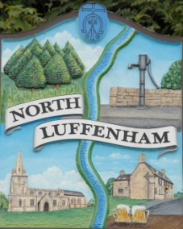
All Councillors are summoned to the Parish Council (Trust) Annual Meeting immediately following the Parish Council Meeting on Monday, 15th May 2017 in the North Luffenham Community Centre
North Luffenham Parish Council

Agenda

- Election of Chair, Vice-Chair
- Apologies
- Declarations of Interest
- To review and confirm Committees & Working Groups for 2017/18
  - Oval/Field Working Group – currently Cllrs Cade, Marson, Sewell and Mr Mike Wyatt

- To approve and sign Minutes as follows:
  - Parish Council (Trust) meeting of 6th March 2017
  - Extraordinary Parish Council (Trust) meeting of 13th March 2017

- To receive an update about progress of outstanding resolutions from the last meetings, i.e. PC Trust and Extraordinary
- Geoff Sewell Close house sales / Spire Homes – Cllr Cummings
- Registration of the united charity – Cllr Riordan
- Woodland Walk notice – Cllr Cade
- Fencing – Clerk
- Trip hazard to the entrance of the Oval in Church Street – Cllr Marson
- Temporary repair to play equipment ramp – Cllr Marson

- To consider revised budget FY17/18 – Cllr Cummings

- Finance Report – Clerk
  - PC to consider and approve Finance Report
  - To note additional spend of £102.83 in relation to hire of flail; (breakdown noted as £336.50 + £66.33 VAT, giving invoice total of £402.83

- Field Gardens Report - Cllr Cade
- Allotments
- Draft Allotment Letting Policy

- Oval Report - Cllr Cade
  - Play Equipment Report
  - Walls

- To approve expenditure of up to £2,000 to conduct a Tree Survey including examination of tree roots of the tree adjacent to the Old School House – Cllr Cummings

- Date of next meeting: Parish Council (Trust) meeting,
Monday, 3rd July 2017

Angela Ashpole, Parish Clerk
9th May 2017

