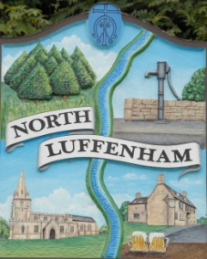
All Councillors are summoned to the Parish Council (Trust) Annual Meeting immediately following the Parish Council Meeting on Monday, 3rd July 2017 in the North Luffenham Community Centre
North Luffenham Parish Council

Agenda

- Apologies: Cllr Riordan, Cllr Inman
- Declarations of Interest
- To approve and sign Minutes of PC Trust meeting of 15th May 2017

- To receive an update about progress of outstanding resolutions from the last meeting:
- Registration of the united charity – Clerk
- Woodland Walk / Allotment gate notice – Cllr Cade
- Trip hazard to the entrance of the Oval in Church Street – Cllr Marson
- Tree survey and inspection – Cllr Cade

- To consider the draft Code of Conduct and Conflicts of Interest Policy for Trust matters – Cllr Cummings

- Finance Report – Clerk
  - To receive Qtr 1 (April-June) Actual/Forecast Budget Summary
  - To consider and approve Finance Report

- To consider a plan to tidy the Oval and make good the cricket pitch following the bonfire event – Cllr Cade

- Field Gardens Report - Cllr Cade
- Allotments update
- Woodland Walk expenses: approval sought by Cllr Cade to spend up to £25 for fuel associated with grass cutting

- To receive and consider the revised Allotment Letting Policy – Cllr Cade

- Oval Report - Cllr Cade
  - Wicksteed Play Equipment - maintenance undertaken on 16/06/2017

- To consider quotes x 3 for specialist painting play equipment – Cllr Cade

- To consider a Family Day – Cllr Cummings
  - to seek permission to provide a Family Day
  - approval sought for a provision of up to £100

- Questions to the Chair: an opportunity for Councillors to raise any questions/comments to the Chair

- Agenda items for discussion at the next meeting

- Date of next Parish Council (Trust) meeting: Monday, 4th September 2017

Angela Ashpole, Parish Clerk, 26th June 2017

