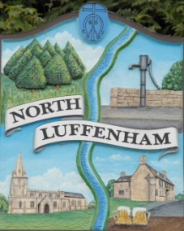
All Councillors are summoned to the Parish Council (Trust) Annual Meeting immediately following the Parish Council Meeting on Monday, 16th October 2017 in North Luffenham Community Centre
North Luffenham Parish Council

Agenda

- Apologies: none
- Declarations of Interest
- To approve and sign Minutes of PC Trust meeting of 4th September 2017

- To receive an update about progress of outstanding resolutions:
- 31/17: Erection of boundary fencing of Manor Farm land adjacent to the Woodland Walkway and supplier address details – Cllr Sewell
- To note that the following should have been discussed within NLPC General meeting of 04/09/2017 – Clerk
  - 32/17 b: approval for Cat 3 Firework training cost
  - 32/17 d: insurance for Bonfire Night Event
  - 35/17: specialist painting for play equipment business
- 34/17 c: Goalposts replacement quotes – Cllr Cummings

- To receive and consider request from NLPC to hold Bonfire Night Event on Sunday 05/11/2017 – Cllr Cummings

- Finance Report – Clerk
  - To consider and approve Trust Finance Report
  - To receive actual against budget report
  - Oval bench repair costs - to seek approval to spend up to £30

- Field Gardens Report – Cllr Cade
- To receive report of NL Allotment Society
- Management of allotment rents/NAS membership/insurance: proposal to seek expert guidance via LRALC
- Woodland Walk: control of Ragwort and suggestion to spray at end of May 2018
- To receive and approve Allotment Lettings Policy

- Oval Report – Cllr Cade
  - To consider current state re Oval grass cutting
  - To consider reports associated with Oval trees
    - Survey Report and Inspection
    - To discuss progress regarding alleged tree root damage
    - Long-term review of trees
  - Play equipment, phase 2: to advertise for volunteer
  - Oval Play Area: to consider quote to supply & fit timber gate and to seek approval to spend £226
- Agenda items for discussion at the next meeting

- To confirm Parish Council meeting dates for next 18 months – Clerk

- Date of next Parish Council (Trust) meeting: Monday, 4th December 2017

Angela Ashpole
Parish Clerk
9th October 2017

