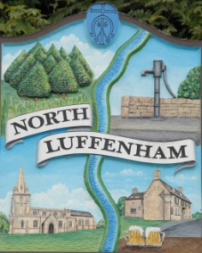
All Councillors are summoned to an Extraordinary Parish Council Meeting on Wednesday 22nd November in the North Luffenham Community Centre at 8pm
North Luffenham Parish Council

The Public may attend the meeting but there will be no Public Forum

Agenda

86/17. Apologies

87/17. Declarations of interest

88/17. Staff Committee Report – Confidential (Closed Session)

89/17. Date of next meeting: PC meeting: Monday 4th December 2017

PBG Cummings
Chairman, NLPC
16 Nov 17

