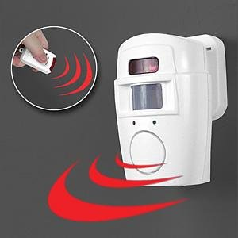 | PIR Sensor Alarm  (Multi-purpose use)  Value for money key fob operated alarm; useful for use in out buildings or attaching to toolboxes or other vulnerable property within sheds etc. Sets off ear piercing alarm if moved. | £6.00
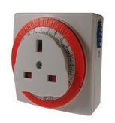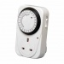 | Socket Timer Switches | £3.00
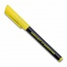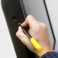 | UV Property Marking Pen | £0.20
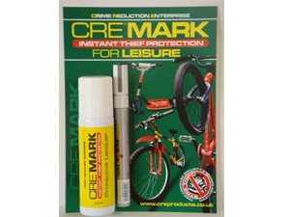 | CRE-MARK large property marking kit | £15.00
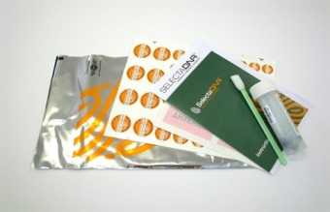 | Home Selecta-Mark Kit  (Complete with on-line registration card) | £12.00
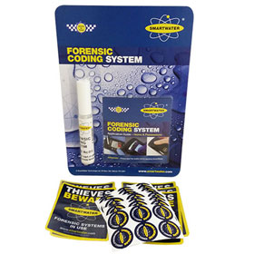 | Household ‘SmartWater’ pack  (Annual Registration fee applies) | £12.00
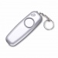 | Defender Slim Line PA Alarm | £3.50
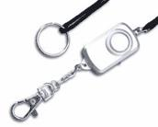 | Mini PA Purse Alarm | £3.50
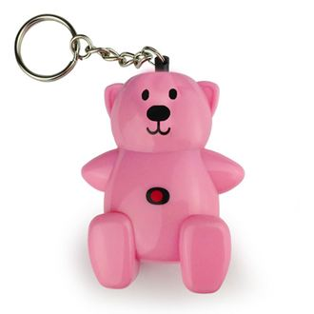 | Teddy Bear Personal Attack Alarm  The Bear Key-ring alarm combines an ear piercing 140 dB alarm with a unique and trendy design. | £3.50
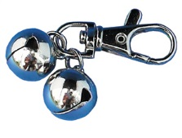 | Purse Bell | £0.50
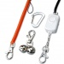  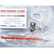 | Purse/Bag Dipping Packs  (items sold separately) | Price  Varies  + VAT
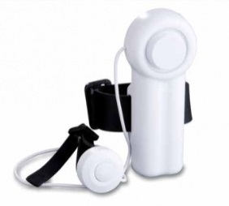 | Mobility Alarm for disabled or older persons  The Mobility Aid Alarm provides all the benefits of a personal alarm whilst its adjustable straps make it suitable for use with crutches, Zimmer frames, walking sticks, mobility devices and wheelchairs. | £4.00
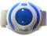 | Jogger Alarm  Fits comfortably on the upper arm for swift single hit activation sets off 130dB siren | £7.50
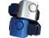 | Wrist alarm  Disguised as a wrist watch, this  PA Alarm emits a 130dB siren when activated | £3.50
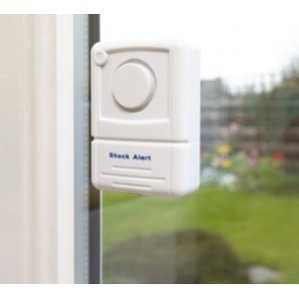 | Window Vibration/Shock Alarm  Small but loud alert alarm is easy to fit to any window in your home. If someone tries to force the window, a loud alarm is triggered. The alarm is suitable for all types of windows as well as glass door panels such as conservatory door glass panels or garden shed windows. | £3.50
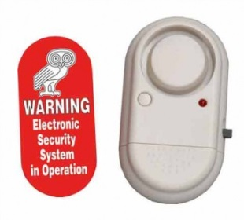 | Defender Window Shock Alarm  Different shape same function 110 dBs alarm. Includes low battery indicator. | £4.00
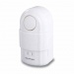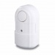 | PIR Charm & Alarm  Innovative new product designed to help prevent sneak in burglary. The alarm has a 30 degree PIR sensor allowing it to detect movement in a specific area, reducing false alarms. Can be used in windows and doors as well as having an added chime function to welcome guests | £6.00
 | Memo Minder  The Memo Minder is a fantastic device which recognises when someone walks past and plays a recorded message. | £12.00
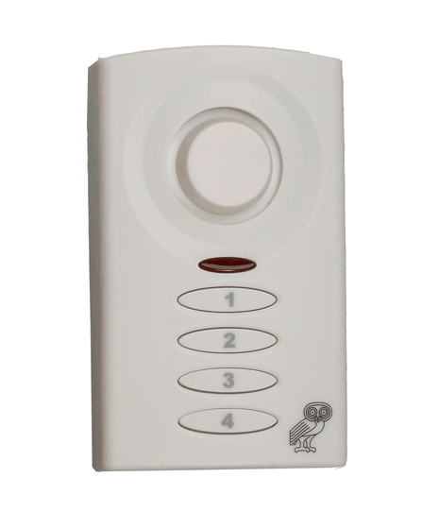 | Shed Keypad Alarm  This easy-to-install alarm helps you to tackle this problem. It is controlled using the 4-digit keypad to arm and disarm the 130+ decibel siren. The alarm has an entry and exit delay system, and the sensitivity is adjustable | £7.50
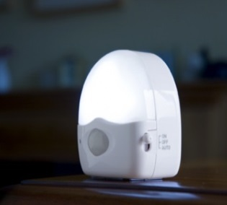 | Motion sensitive LED light  Ideal for preventing Trips and falls as illuminates when motion is detected in low light situations.  Energy saving daylight sensor ensures unit only operates at night saving battery power.  Small, attractive design, ideal for use in store rooms, hallways and entrances. | £5.00
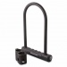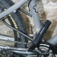 | Cycle D Locks | £6.00-£10
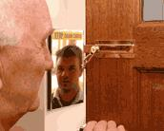 | Era Door Chain  Seen here in use with a door mirror which allows a view of doorstep caller. | £4.00  (mirror £1)
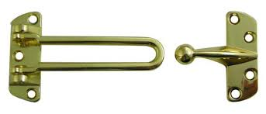 | Era Door Bar Restrictor | £4.00
 | UPVC Door Chain | £5.00
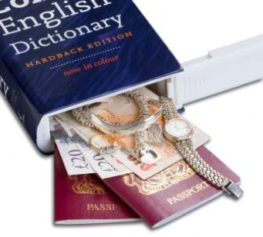 | Collins Dictionary Safe  Doesn’t look out of place on the bookshelf | £5.00
 | Safe Cans  Useful container for valuables & keys | £2.50
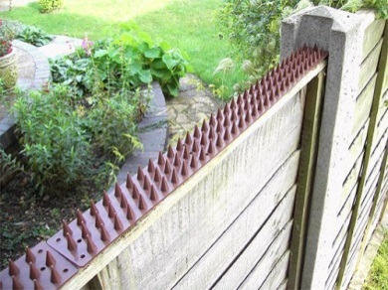 | Tip Top Fence Spikes  Packs of 10 with warning sign | £8.00
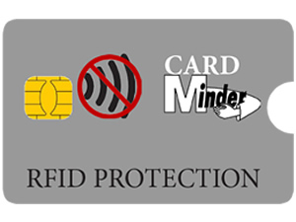 | RFID Protection Wallet  Protect your Credit Card with  a purpose made RFID wallet. | £0.50p
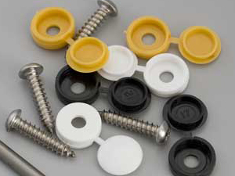 | Vehicle Number Plate  Screws kit  DIY Easy to fit multi size screws | £1.00
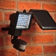 | Defender Max Solar Security Light  Extremely bright, with 60 super-bright white LED's providing 850 lumens of light. | £30.00

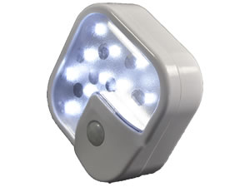 Solar Powered Motion Sensor Light £5

Useful as a welcome home driveway light.

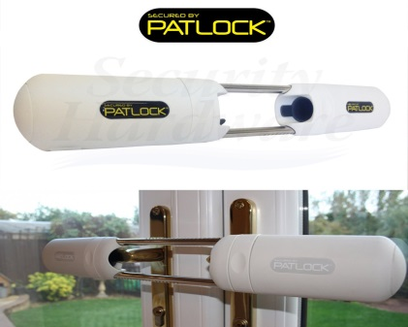

Instant French Door Security Lock £34.50

Supplied by ‘Patlock’ Ltd this is a really effective way to secure double handled French doors.

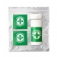 Fridge Medical Alert Pack £2

Can be used to provide Emergency Services with vital medical information such allergies or current medication. Plus ‘In Case of Emergency’ (ICE) details.

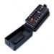Defender Key Safe £20

Large capacity key safe: easy to fit, easy to use push button key safe with neoprene weatherproof disguise

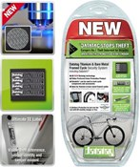
Data-tag Cycle Security Pack ~ £18.99 (Standard) & £22.99 (Professional)
Advanced Security Identification System for Bicycles with Bare Metal Frames
This new Data-tag system designed exclusively for all bikes except bare metal frames (titanium or stainless steel) is simple to fit. It uses both visible and hidden identifiers including the latest state-of-the-art Datadot (R) and QR Code technology to give your bike a unique finger print.

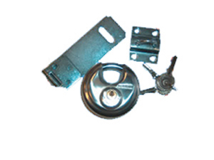Discus Padlock Safety Hasp and Eye ~ £10

Ideal for securing sheds ~ can be supplied separately
Hasp & Eye: £4
Padlock: £6

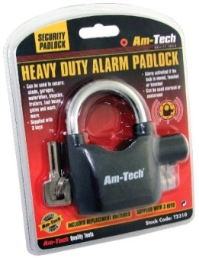 | Multi-Purpose Padlock Alarm  As an alarm - to deter intruders simply replace the shackle in the correct position and lock. After a short delay the alarm is active and will sound a warning beep if tampered with. If further movement is detected the padlock will sound an impressive two tone siren scaring off would be thieves. | £8.50

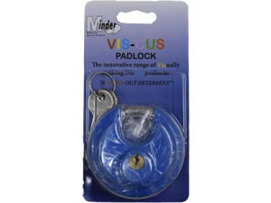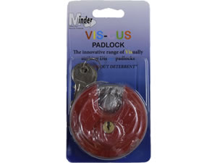

Coloured disc locks £5
A closed shackled padlock as well as being a colourful deterrent.
Various colours.

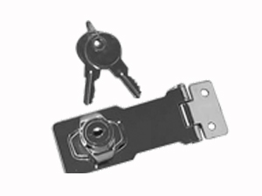Locking Hasp and Eye £6

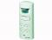Shed Alarm now in Brown £9

This easy-to-install alarm helps you to tackle this problem. It is controlled using the 4-digit keypad to arm and disarm the 130+ decibel siren. The alarm has an entry and exit delay system, and the sensitivity is adjustable

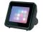TV Simulator £16

NEW Simulated TV Mark III, designed to simulate a real working TV. The product gives the impression that a property is occupied.

