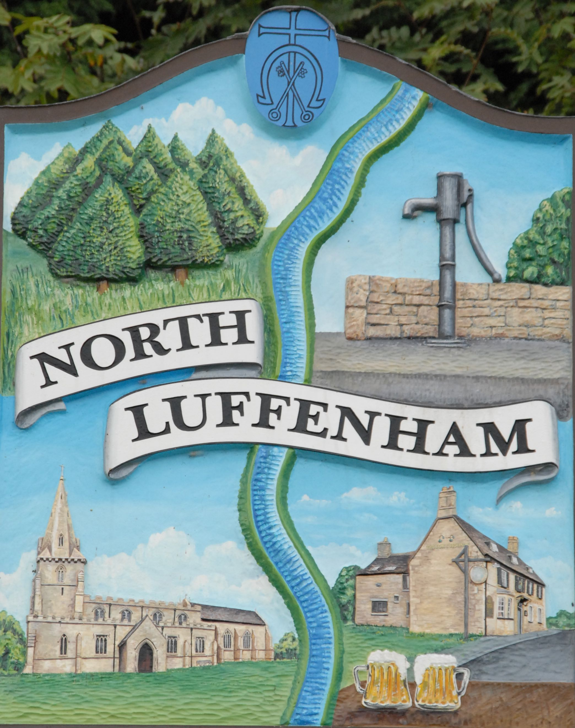
NORTH LUFFENHAM PARISH COUNCIL
GENERAL PRIVACY NOTICE

Your personal data – what is it?
“Personal data” is any information about a living individual which allows them to be identified from that data (for example a name, photographs, videos, email address, or address). Identification can be directly using the data itself or by combining it with other information which helps to identify a living individual (e.g. a list of staff may contain personnel ID numbers rather than names but if you use a separate list of the ID numbers which give the corresponding names to identify the staff in the first list then the first list will also be treated as personal data). The processing of personal data is governed by legislation relating to personal data which applies in the United Kingdom including the General Data Protection Regulation (the “GDPR) and other legislation relating to personal data and rights such as the Human Rights Act.
Who are we?
This Privacy Notice is provided to you by North Luffenham Parish Council which is the data controller for your data.
Other data controllers the council works with:
- Other Data Controllers including Rutland County Council
- Community groups
- Charities
- Other not for profit entities
- Contractors

We may need to share your personal data we hold with them so that they can carry out their responsibilities to the council. If we and the other data controllers listed above are processing your data jointly for the same purposes, then the council and the other data controllers may be “joint data controllers” which mean we are all collectively responsible to you for your data. Where each of the parties listed above are processing your data for their own independent purposes then each of us will be independently responsible to you and if you have any questions, wish to exercise any of your rights (see below) or wish to raise a complaint, you should do so directly to the relevant data controller.
A description of what personal data the council processes and for what purposes is set out in this Privacy Notice.
The council will process some or all of the following personal data where necessary to perform its tasks:
- Names, titles, and aliases, photographs;
- Contact details such as telephone numbers, addresses, and email addresses;
- Where they are relevant to the services provided by a council, or where you provide them to us, we may process information such as gender, age, marital status, nationality, education/work history, academic/professional qualifications, hobbies, family composition, and dependants;
- Where you pay for activities such as use of an allotment, financial identifiers such as bank account numbers, payment card numbers, payment/transaction identifiers, policy numbers, and claim numbers;
- The personal data we process may include sensitive or other special categories of personal data such as criminal convictions, racial or ethnic origin, mental and physical health, details of injuries, medication/treatment received, political beliefs, trade union affiliation, genetic data, biometric data, data concerning and sexual life or orientation.
How we use sensitive personal data
- We may process sensitive personal data including, as appropriate:
  - information about your physical or mental health or condition in order to monitor sick leave and take decisions on your fitness for work;
  - your racial or ethnic origin or religious or similar information in order to monitor compliance with equal opportunities legislation;
  - in order to comply with legal requirements and obligations to third parties.
- These types of data are described in the GDPR as “Special categories of data” and require higher levels of protection. We need to have further justification for collecting, storing and using this type of personal data.
- We may process special categories of personal data in the following circumstances:
  - In limited circumstances, with your explicit written consent.
  - Where we need to carry out our legal obligations.
  - Where it is needed in the public interest.
- Less commonly, we may process this type of personal data where it is needed in relation to legal claims or where it is needed to protect your interests (or someone else’s interests) and you are not capable of giving your consent, or where you have already made the information public.
Do we need your consent to process your sensitive personal data?
- In limited circumstances, we may approach you for your written consent to allow us to process certain sensitive personal data. If we do so, we will provide you with full details of the personal data that we would like and the reason we need it, so that you can carefully consider whether you wish to consent.
The council will comply with data protection law. This says that the personal data we hold about you must be:
- Used lawfully, fairly and in a transparent way.
- Collected only for valid purposes that we have clearly explained to you and not used in any way that is incompatible with those purposes.
- Relevant to the purposes we have told you about and limited only to those purposes.
- Accurate and kept up to date.
- Kept only as long as necessary for the purposes we have told you about.
- Kept and destroyed securely including ensuring that appropriate technical and security measures are in place to protect your personal data to protect personal data from loss, misuse, unauthorised access and disclosure.
We use your personal data for some or all of the following purposes:
- To deliver public services including to understand your needs to provide the services that you request and to understand what we can do for you and inform you of other relevant services;
- To confirm your identity to provide some services;
- To contact you by post, email, telephone or using social media (e.g., Facebook, Twitter, WhatsApp);
- To help us to build up a picture of how we are performing;
- To prevent and detect fraud and corruption in the use of public funds and where necessary for the law enforcement functions;
- To enable us to meet all legal and statutory obligations and powers including any delegated functions;
- To carry out comprehensive safeguarding procedures (including due diligence and complaints handling) in accordance with best safeguarding practice from time to time with the aim of ensuring that all children and adults-at-risk are provided with safe environments and generally as necessary to protect individuals from harm or injury;
- To promote the interests of the council;
- To maintain our own accounts and records;
- To seek your views, opinions or comments;
- To notify you of changes to our facilities, services, events and staff, councillors and other role holders;
- To send you communications which you have requested and that may be of interest to you. These may include information about campaigns, appeals, other new projects or initiatives;
- To process relevant financial transactions including grants and payments for goods and services supplied to the council
- To allow the statistical analysis of data so we can plan the provision of services.
Our processing may also include the use of CCTV systems for the prevention and prosecution of crime.
What is the legal basis for processing your personal data?
The council is a public authority and has certain powers and obligations. Most of your personal data is processed for compliance with a legal obligation which includes the discharge of the council’s statutory functions and powers. Sometimes when exercising these powers or duties it is necessary to process personal data of residents or people using the council’s services. We will always take into account your interests and rights. This Privacy Notice sets out your rights and the council’s obligations to you.
We may process personal data if it is necessary for the performance of a contract with you, or to take steps to enter into a contract. An example of this would be processing your data in connection with the use of sports facilities, or the acceptance of an allotment garden tenancy
Sometimes the use of your personal data requires your consent. We will first obtain your consent to that use.
Sharing your personal data
This section provides information about the third parties with whom the council may share your personal data. These third parties have an obligation to put in place appropriate security measures and will be responsible to you directly for the manner in which they process and protect your personal data. It is likely that we will need to share your data with some or all of the following (but only where necessary):
- The data controllers listed above under the heading “Other data controllers the council works with”;
- Our agents, suppliers and contractors. For example, we may ask a commercial provider to publish or distribute newsletters on our behalf, or to maintain our database software;
- On occasion, other local authorities or not for profit bodies with which we are carrying out joint ventures e.g. in relation to facilities or events for the community.
How long do we keep your personal data?
We will keep some records permanently if we are legally required to do so. We may keep some other records for an extended period of time. For example, it is currently best practice to keep financial records for a minimum period of 8 years to support HMRC audits or provide tax information. We may have legal obligations to retain some data in connection with our statutory obligations as a public authority. The council is permitted to retain data in order to defend or pursue claims. In some cases the law imposes a time limit for such claims (for example 3 years for personal injury claims or 6 years for contract claims). We will retain some personal data for this purpose as long as we believe it is necessary to be able to defend or pursue a claim. In general, we will endeavour to keep data only for as long as we need it. This means that we will delete it when it is no longer needed.
Your rights and your personal data
You have the following rights with respect to your personal data:
When exercising any of the rights listed below, in order to process your request, we may need to verify your identity for your security. In such cases we will need you to respond with proof of your identity before you can exercise these rights.
  - The right to access personal data we hold on you
- At any point you can contact us to request the personal data we hold on you as well as why we have that personal data, who has access to the personal data and where we obtained the personal data from. Once we have received your request we will respond within one month.
- There are no fees or charges for the first request but additional requests for the same personal data or requests which are manifestly unfounded or excessive may be subject to an administrative fee.
  - The right to correct and update the personal data we hold on you
- If the data we hold on you is out of date, incomplete or incorrect, you can inform us and your data will be updated.
  - The right to have your personal data erased
- If you feel that we should no longer be using your personal data or that we are unlawfully using your personal data, you can request that we erase the personal data we hold.
- When we receive your request we will confirm whether the personal data has been deleted or the reason why it cannot be deleted (for example because we need it for to comply with a legal obligation).
  - The right to object to processing of your personal data or to restrict it to certain purposes only
- You have the right to request that we stop processing your personal data or ask us to restrict processing. Upon receiving the request we will contact you and let you know if we are able to comply or if we have a legal obligation to continue to process your data.
  - The right to data portability
- You have the right to request that we transfer some of your data to another controller. We will comply with your request, where it is feasible to do so, within one month of receiving your request.
  - The right to withdraw your consent to the processing at any time for any processing of data to which consent was obtained
- You can withdraw your consent easily by telephone, email, or by post (see Contact Details below).
  - The right to lodge a complaint with the Information Commissioner’s Office.
- You can contact the Information Commissioners Office on 0303 123 1113 or via email https://ico.org.uk/global/contact-us/email/ or at the Information Commissioner's Office, Wycliffe House, Water Lane, Wilmslow, Cheshire SK9 5AF.
Transfer of Data Abroad
Any personal data transferred to countries or territories outside the European Economic Area (“EEA”) will only be placed on systems complying with measures giving equivalent protection of personal rights either through international agreements or contracts approved by the European Union. [Our website is also accessible from overseas so on occasion some personal data (for example in a newsletter) may be accessed from overseas].
Further processing
If we wish to use your personal data for a new purpose, not covered by this Privacy Notice, then we will provide you with a new notice explaining this new use prior to commencing the processing and setting out the relevant purposes and processing conditions. Where and whenever necessary, we will seek your prior consent to the new processing.
Changes to this notice
We keep this Privacy Notice under regular review and we will place any updates on this web page: www.northluffenham.com This Notice was last updated in May 2018.
Contact Details
Please contact us if you have any questions about this Privacy Notice or the personal data we hold about you or to exercise all relevant rights, queries or complaints at:
The Data Controller, North Luffenham Parish Council. c/o The Parish Clerk, 7 Rosewood Close, North Luffenham LE15 8LQ.
Email: nlparishclerk@outlook.com

