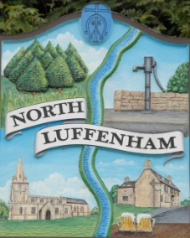
All Councillors are summoned to the Parish Council (Trust) Annual Meeting immediately following the Parish Council Meeting on Monday, 21st May 2018 in the North Luffenham Community Centre
North Luffenham Parish Council

Agenda

1/18 Election of Chair, Vice-Chair
2/18 Apologies
3/18 Declarations of Interest
4/18 To review and confirm Committees & Working Groups for 2018/1918
Oval/Field Working Group – currently Cllrs Cade, Sewell and Mr Mike Wyatt

5/18 To approve and sign Minutes as follows:
  - Parish Council (Trust) meeting of 5th March 2018
  - Extraordinary Parish Council (Trust) meeting of 9th April
  - Extraordinary Parish Council (Trust) meeting of 10th May 2018

6/18 To receive an update about progress of outstanding resolutions from the last meetings, i.e. PC Trust and Extraordinary
- Geoff Sewell Close house sales / Spire Homes – Cllr Cummings
- Registration of the united charity – Cllr Riordan
- Woodland Walk notice – Cllr Cade
- Dealing with Ragwort infestation – Cllr Cade
- Play equipment report and recommendation for future work – Cllr Cade
- Proposal for additional Equipment – Cllr Cade

7/18 Finance Report – Cllr Cummings
- To consider and approve payment of £204.29 Mow All for April mowing
- To consider and a maximum payment of £250 for weed-killer and sprayer re Ragwort Infestation

8/18 Field Gardens Report - Cllr Cade
- Allotments

9/18 Oval Report - Cllr Cade
  - RCC Tree survey report
  - EWGS Woodland Management Grant

10/18 North Luffenham Cricket Club Working Group – Cllr Cummings

11/18 Update apparent tree root damage– Cllr Cummings

12/18 Date of next meeting: Parish Council (Trust) meeting,
Monday, 2nd July 2018

John Willoughby
Parish Clerk 14th May 2018

