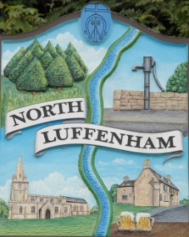
Notice is hereby given that there will be a meeting of
the Planning Committee of North Luffenham Parish Council on Tuesday, 12 June 2018 at 4.00 pm in the North Luffenham Community Centre.
North Luffenham Parish Council

Members of the public will have an opportunity to give their views on the applications.
Agenda
- Introduction
- Apologies
- Declarations of Interest

- Planning Applications - to discuss the following:

  - 2018/0358/FUL, 12 Glebe Road, North Lufenham – proposal: Demolition of house and garage and replacement with new 4 bed dwelling including detached garage. Erection of new front gates and fencing.

John Willoughby
Parish Clerk
6th June 2018

