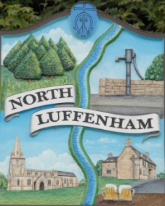
All Councillors are summoned to the Parish Council (Trust) Meeting immediately following the Parish Council Meeting on Monday, 2nd July 2018 in the North Luffenham Community Centre
North Luffenham Parish Council

Agenda

01/18 Apologies: Cllr Riordan, Cllr Burrows
02/18 Declarations of Interest
03/18 To approve and sign Minutes of PC Trust meeting of 21st May 2018

04/18 Finance Report – Clerk
  - To receive Qtr 1 (April-June) Actual
  - To consider and approve Finance Report
  - To seek approval for contracted services payments in line with that contract to be paid on receipt of invoice and confirmation that the work has been satisfactorily carried out; as per Financial Regulations section 5 sub-sections 5.5/5.6

05/18 To consider and agree the following payments:
- Mow All – May grass cutting £204.29
- 4 Counties – Grass Cutting £80.00
- Cllr Cade – Re-imbursement of spray costs re Woodland walk £59.88

06/18 Field Gardens Report - Cllr Cade
- Allotments update
- Review signage on Allotments Gate

06/18 Oval Report - Cllr Cade
  - Play Equipment – To receive a report on proposals for new play equipment and goal posts.

07/18 To receive an update re insurance claim for tree root damage to resident’s property: Clerk

08/18: To receive a proposal to open a new Bank account with HSBC to meet the Charity Commission requirement that the Charities bank account reflects its charitable status; the account to be titled; N Luffenham Field Garden & Recreation Ground Charity No 1173697. Upon opening to transfer the funds from the hold accounts and then arrange closure of such. Clerk

09/18 Agenda items for discussion at the next meeting

10/18 To receive a proposal to bring forward the next Parish Council (Trust) meeting from Monday, 3rd September 2018 to Tuesday 28th August

John Willoughby, Parish Clerk, 25th June 2018

