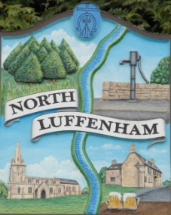
North Luffenham Parish Council

All Councillors are summoned to an Extraordinary Parish Council Meeting on Thursday 20th Sep 2018 at 8pm in the
North Luffenham Community Centre

The public may attend the meeting but there will be no Public Forum

Agenda

56/18 Apologies
57/18 Declarations of Interest
58/18 To receive a verbal report from Cllr Cummings on the discussion at the RCC Advisory Group meeting on 13th Sep 18

59/18 Consideration of NLPC response to Rutland Local Plan Review – Specific Consultation considering the implications of potential development of St George’s within the Local Plan
60/18 Consideration of NLPC response to Rutland Local Plan Review Consultation Draft Plan Additional Sites

Dates of next meeting:

a. Parish Council Meeting – 25th October 18

PBG Cummings
Parish Council Chairman
6 September 2018

