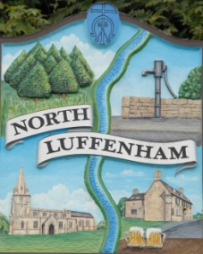
All Councillors are summoned to the Parish Council (Trust) Meeting immediately following the Parish Council Meeting on Monday 22nd October 2018 in the North Luffenham Community Centre
North Luffenham Parish Council

Agenda

25/18 Apologies:
26/18 Declarations of Interest
27/18 To approve and sign minutes of PC Trust meeting 28th August 2018

28/18 Finance Report – Clerk
  - To receive a report from Cllr – Bank Reconciliation 28th August 2018
  - To receive report (April to September) actual
  - To consider and approve the finance report
  - To note the following payments:
- Mow All £204.29 Grass cutting August
- Mow All £204.29 Grass Cutting September
- 4 Counties Ground Maintenance £160 cuts 6&7
- 4 Counties Ground Maintenance £240 cuts 8,9,10
- 4 Counties Ground Maintenance £160 cuts 11&12
e. To receive and approve the following payments:
- £110.48 for the tree report carried out by RCC
- £60 for new signage to allotments Caffarelli Designs
- £256.80 for hire of grass cutter, HSS Hire
- £14.17 Petrol for grass cutting machine, MRH Retail and Adams & Son

29/18 To receive and review the initial draft of the financial budget for the year 1st April 2019 to 31st March 2020

30/18. Field Gardens Report - Cllr Cade
- Allotments update
- Report on Grass Cutting to Woodland Walk

31/18 . Oval Report - Cllr Cade

  - Bench – To consider the request from a resident to have a bench/seat sited at the top end of the Oval
  - To obtain a quote for the repair to the boundary stone wall to the rear of 3 Oval Close

32/18. Agenda items for discussion at the next meeting

33/18 Chair to seek approval to close the meeting to the public to discuss item 34/18 in confidence

34/18. To receive an update re the insurance claim for tree root damage to resident’s property. Papers attached

35/18. Date of next meeting: Monday 3rd December 2018, 7pm

John Willoughby, Parish Clerk
15th October 2018

