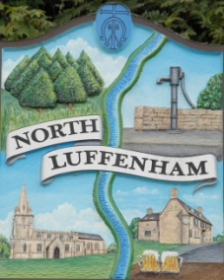
Councillors are summoned to the Parish Council (Trust) Meeting immediately following the Parish Council Meeting on Monday 3rd December 2018 in the North Luffenham Community Centre
North Luffenham Parish Council

Agenda

36/18 Apologies
37/18 Declarations of Interest
38/18 To approve and sign minutes of PC Trust meeting 22nd October 2018

39/18 Chair to seek approval to close the meeting to the public to discuss item 40/18 in confidence

40/18 To receive an update re the insurance claim for tree root damage to resident’s property

41/18 Finance Report – Clerk
  - To receive a report from Cllr Smith– Bank Reconciliation 18 Nov 2018
  - To receive report (April to October) actual
  - To consider and approve the finance report
  - To note the following payments:
- Mow All £204.29 Grass cutting October
e. To receive and approve the following payments:
- £1196 +vat; George Walker Tree Care

42/18 To receive and review the final draft of the financial budget for the year 1st April 2019 to 31st March 2020

43/18 Field Gardens Report - Cllr Cade
- Allotments update: To receive and approve the review of allotment rents for 2019 excluding Insurance and NAS subs: Proposal to increase a full allotment rent to £36 (currently £33), half allotment to £22 (currently £20) and quarter allotment to £15 (currently £12)

44/18 Oval Report - Cllr Cade

  - Bench – To receive and approve the cost of installing an additional bench at the top of the Oval in line with the other benches sited on the Oval; £346 +vat (Quote attached)
  - To obtain a quote for the repair to the boundary stone wall to the rear of 3 Oval Close

45/18 Agenda items for discussion at the next meeting

46/18 To consider dates for future Trust meetings covering the period April 2019 to March 2020

47/18 Date of next meeting: Monday 21st January 2019 @ 7pm

John Willoughby, Parish Clerk
27th November 2018

