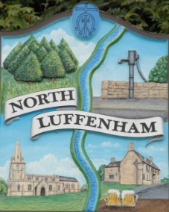
Councillors are summoned to the Parish Council (Trust) Meeting immediately following the Parish Council Meeting on Monday 28th January 2019 in the North Luffenham Community Centre
North Luffenham Parish Council

Agenda

01/19 Apologies
02/19 Declarations of Interest
03/19 To approve and sign minutes of PC Trust meeting 3rd Dec 2018

04/19 Finance Report – Clerk
  - To receive a report from Cllr Bob Sewell– Bank Reconciliation 31 Dec 2018
  - To receive report (April to December) actual
  - To consider and approve the finance report
  - To review and confirm the revised final budget for 2019/20
  - To receive and approve the following payments
- C Cade Concrete post mix and stakes £74.64
- Shield Insurance re Allotments Public liability Ins £160.51
f. To note receipt of the wayleave payment of £8.05 from Western Power

05/19 To receive, review and approve the quotes for mowing 2019
- Mow All £1500.03. 7 Invoices of £214.29. This represents an increase of £10 pm on 2018
- 4 Counties Ground Maintenance £2,250, being £90 per cut, an increase of £10 per cut on 2018

06/19 Field Gardens Report - Cllr Cade
- Allotments update: To note that invoices for 2019 have been sent to allotment holders

07/19 Oval Report - Cllr Cade

  - To obtain a quote for the repair to the boundary stone wall to the rear of 3 Oval Close
  - To note that invoices have been issued to both the Bowls Club, £20 and the Cricket Club, £50, being rents due and that payments have been received.

08/19 To consider creating a specific policy for the management of works carried out by 3rd Parties.

09/19 Date of next meeting: Monday 4th March 2019 @ 7pm

John Willoughby,
Parish Clerk
22nd January 2019

