Bus Users Group Meeting
Tuesday 26th March 2019

The Museum, Catmose, Oakham 10:15 am – 11:45 am

The Rutland Bus Users Group are opening up their next meeting to Rutland residents and users of public transport for an opportunity to meet with and put questions to local bus operators and the Rutland County Council Transport Team. You will also be able to find out more about joining the Bus Users Group.

If you would like to attend then doors will open to the public at 10:00 am for a prompt start.
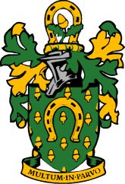

Rutland County Council

