Stand as a Parish Councillor
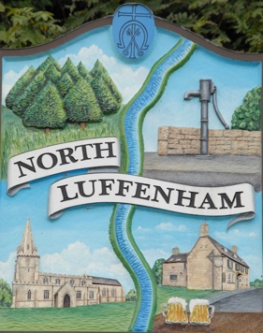 | Polling Day:  Thursday 2 May 2019
Make a difference to your Parish Council
- Get involved with your community
- Have a say about the local issues people care about
- Influence local service delivery
- Decide how local money is spent to improve your community
For nomination packs contact:
Mr John Willoughby
Parish Clerk, North Luffenham Parish Council
Tel: 01780 729283

Produced by Leicestershire and Rutland Association of Local Councils www.leicestershireandrutlandalc.gov.uk/elections.html

