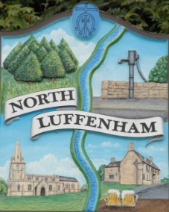
Councillors are summoned to the Parish Council (Trust) Meeting immediately following the Parish Council Meeting on Monday 4th March 2019 in the North Luffenham Community Centre
North Luffenham Parish Council

Agenda

10/19 Apologies
11/19 Declarations of Interest
12/19 To approve and sign minutes of PC Trust meeting 28th January 2019

13/19 Chair to seek approval to close the meeting to the public to discuss item 14/18 in confidence

14/18 To receive an update re the insurance claim for tree root damage to resident’s property

15/19 Finance Report – Clerk
  - To receive a report from Cllr Bob Sewell– Bank Reconciliation 28th February 2019
  - To receive report (1st April 2018 to 28th February 2019) actual
  - To consider and approve the finance report
  - To receive and approve the following payments:
- Wicksteed Leisure Ltd £60+vat re play equipment annual inspection and report
- Trevor Johnson £468.00 re replacement of roof to play equipment.
- Mike Wyatt £96 re National Allotment Society subs (32 allotment holders x £3)
16/19 Field Gardens Report - Cllr Cade
- Allotments update: To note that all allotment rents have been paid for 2019 with a total income of £1090.00 and that there are 3 quarter plots still available for rent

17/19 Oval Report - Cllr Cade

  - To obtain a quote for the repair to the boundary stone wall to the rear of 3 Oval Close
  - To receive and consider a request from Western Power to lay HV and LV cabling under the Oval in accordance with the attached plan

18/19 Update on agreeing a policy for works carried out by 3rd Parties on behalf of the Parish Council. Clerk

19/19 Date of next meeting: Monday 15th April 2019 @ 7pm

John Willoughby,
Parish Clerk
25th February 2019

