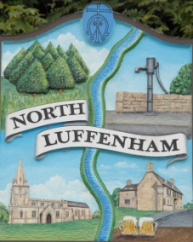
North Luffenham Parish Council

All Councillors are summoned to the Parish Council Extraordinary Meeting on Monday 29th April 2019 at 7pm which will take place in the North Luffenham Community Centre

Agenda

The public may attend the meeting but there will be no Public Forum

34/19 Apologies:
35/19 Declarations of Interest
36/19 Chairman’s Report.

37/19 Finance Report – Clerk

  - To receive the draft financial report for the financial year 1st April 2018 to 31st March 2019.
  - To consider and approve Finance Report
  - To receive and approve the following payments:
- £56.01; Printing of March Newsletter
- £210.00; LRALC re Internal Audit Fee
- £200.00 + VAT; re External Audit PFK Littlejohn
- £40.00; LRALC re clerk training for year end finances course
- £40.00; ICO re data protection renewal fee
- £424.00; Trevor Johnson, repairs to notice Board
- £229.01; NALC/LRALC membership fees
- £67.00; DM Payroll. Annual fee
- £26.80; Purchase of 8 litter pickers

38/19 Conduct routine review of Parish Council Risk Analysis

39/19 To consider membership of The Council for the Protection of Rural England (CPRE). See link: https://www.cpre.org.uk/

40/19 To consider the actions needed of retiring Councillors and data protection requirements

41/19 Planning Cllr Smith

Reference: 2019/0346/FUL
PROPOSAL: Construction of attached triple garage and barn and erection of kitchen garden wall. Ketton Fields Ketton Road North Luffenham Rutland PE9 3UT

42/19 Date of next meeting: Annual Parish Council Meeting; Monday 20th May 2019 @7pm

John Willoughby
Parish Clerk
23rd April 2019

