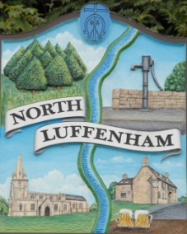
All Councillors are summoned to the Parish Council (Trust) Annual Meeting immediately following the Parish Council Meeting on Monday, 20th May 2019 in the North Luffenham Community Centre
North Luffenham Parish Council

Agenda

26/19. Election of Chair,
27/19. Election of Vice-Chair
28/19. Apologies
29/19. Declarations of Interest
30/19. To review and confirm Committees & Working Groups for 2019/2020:
Oval/Field Working Group – currently Cllrs Cade, Sewell and Mr Mike Wyatt

31/19. To approve and sign Minutes as follows:
  - Parish Council (Trust) meeting of 4th March 2019
  - Extraordinary Parish Council (Trust) meeting of 29th April 2019

32/19. To receive an update about progress of outstanding resolutions from the last meetings, i.e. PC Trust and Extraordinary
- Geoff Sewell Close house sales / Spire Homes – Cllr Cummings
- Dealing with Ragwort infestation – Cllr Sewell

33/19. Finance Report – Clerk
  - To receive a report from Cllr Bishop– Bank Reconciliation to 30th April 2019
  - To consider and approve the finance report
  - To consider and approve the transfer of £6,500.00 from the business manager account to the cheque account to cover outstanding payments
  - To receive and approve the following payments
- £5,544.00 plus vat of £1108.80 (total £6,652.80) George Walker Tree Care Ltd re Cat 4 works
- £214.29; Mow All April Cuts

34/19. Field Gardens Report - Cllr Cade
- Allotments

35/19. Oval Report - Cllr Cade
- RCC Tree survey report
- EWGS Woodland Management Grant

36/19. North Luffenham Cricket Club Working Group – Cllr Cummings

37/19. Update apparent tree root damage– Cllr Cummings

38/19. Date of next meeting: Parish Council (Trust) meeting,
Monday, 1st July 2019

John Willoughby
Parish Clerk
12th May 2019

