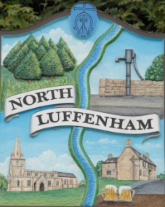
North Luffenham Parish Council

All Councillors are summoned to the Parish Council Meeting on Monday 1st July 2019 at 7pm which will take place in the North Luffenham Community Centre

Agenda

67/19 Apologies:
68/19 Declarations of Interest
69/19 Public Forum
70/19 To approve and sign minutes of PC meeting:
- Annual Parish Council Meeting 20th May 2019

71/19 Chairman’s Report.
- Report on the Informal Strategy day

72/19 To receive an update of St George’s Barracks Development. – Cllr Cummings

73/19 Correspondence – Clerk
- Citizens Advice Rutland – Request for funding
- Gary Chisholm: GSL Ist North Luffenham Scouts
74/19 Finance Report – Clerk

  - To receive a report from Cllr Sewell – Bank Reconciliation 31st May 2019
  - To consider and approve Finance Report
  - To receive and approve the following payments:
  - To note the following payments have been made in accordance with contractual agreements:
- £1,186.51; JWilloughby Clerks salary
- £2,946.40; HMRC

75/19 Planning: Cllr Burrows
PROPOSAL: Reference: 2019/0487/FUL The Coach House 10A Church Street
Alteration and extension to form two bedrooms with ensuite facilities and
utility/boot room to an existing residential dwelling. Insertion of first floor juliet balcony to existing side (south) elevation.

76/19 To receive an update on RCC policy in respect of affordable housing in Geoff Sewell Close- Cllr Cummings

77/19 To receive a report on progress to updating website – Cllr Burrows

78/19 To receive an update on the situation with regard to the Community Centre. - Cllr Cade

79/19 To receive, consider and approve the Terms of Reference of the IT Working Group

80/19 To consider initial ideas/plans with regard to VE Day Celebrations in May 2020

81/19 Date of next meeting: Monday 2nd September 2019, 7pm North Luffenham Community Centre.

John Willoughby
Parish Clerk

