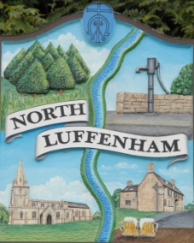
Councillors are summoned to the Parish Council (Trust) Meeting immediately following the Parish Council Meeting on Monday 1st July 2019 in the North Luffenham Community Centre
North Luffenham Parish Council

Agenda

39/19 Apologies
40/19 Declarations of Interest
41/19 To approve and sign minutes of PC Trust meeting 20th May 2019

42/19 Finance Report – Clerk
  - To receive a report from Cllr Sewell– Bank Reconciliation 18th June 2019
  - To consider and approve the finance report
  - To note a VAT claim of £1108.80 for the period 1st April 2019 to 31st May 2019.
  - To receive and approve the following payments
- £20.74; C Cade re paint for Oval gates
- £61.20; C Cade re Fence posts for Woodland walk
  - To not the following contractual payments
- £214.29; Mow All May payment
- £270.00; 4 Counties April mowing (3 cuts)
- £270.00; 4Counties May Mowing (3 cuts)

43/19 Field Gardens Report - Cllr Cade
- Allotments update:
- Woodland Walk update

44/19 Oval Report - Cllr Cade

  - To receive and consider the report from RCC Forestry Officer re replacement tree strategy
  - To receive, consider and approve the increased cost of £1,590.00 plus vat to cut down the small leave lime tree (no 236) by George Walker Tree Care. The original quoted price was £440.00 plus vat.

45/19 Date of next meeting: Monday 2nd September 2019 @ 7pm

John Willoughby,
Parish Clerk

