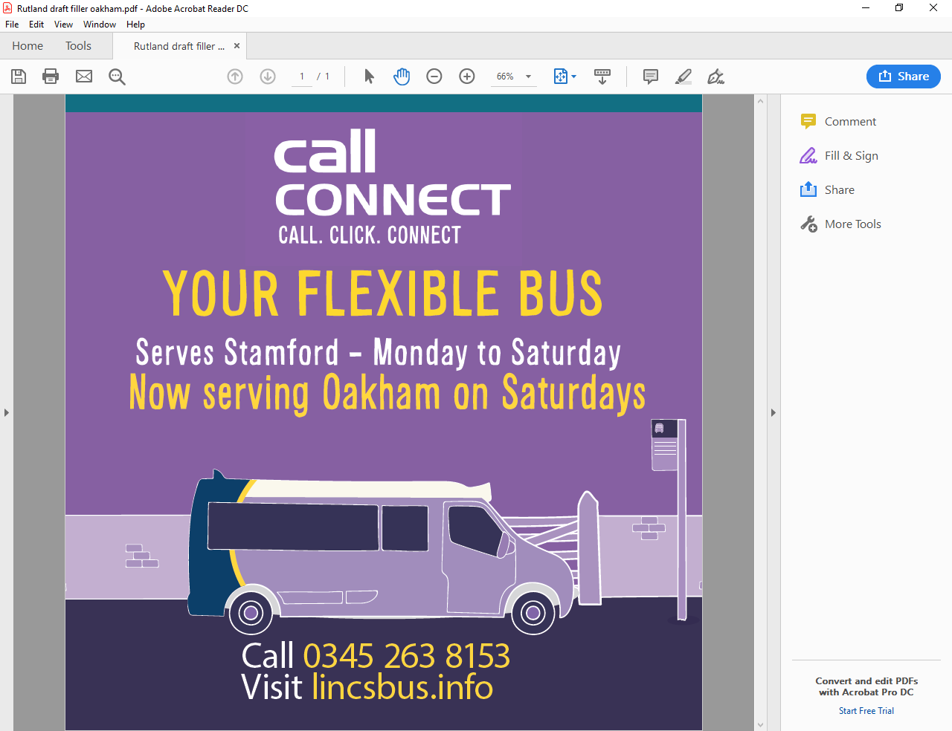

Find out more about your

CallConnect Bus Service at

the ***CallConnect Roadshow***

Wednesday 21st August 2019

**North Luffenham, Pinfold Lane**

1345 - 1430

Find out how to register; locations served; fares; how to book; check out the bus, and more …..

……

