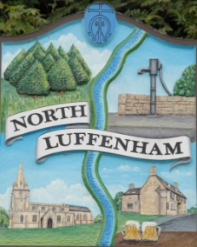
North Luffenham Parish Council

All Councillors are summoned to the Parish Council Extraordinary Meeting on Tuesday 30th July 2019 at 7.30 pm which will take place in the North Luffenham Community Centre

Agenda

The public may attend the meeting but there will be no Public Forum

82/19 Election of chair
83/19 Election of Vice-chair
84/19 Apologies
85/19 Declarations of Interest

86/19 Finance Report – Clerk

  - To report on progress re NLPC change of Bank Mandate with HSBC

87/19 Planning Cllr Burrows

Decision Approval Notice: PROPOSAL: Reduce Hornbeam trees as part of hedgerow by 3 metres. LOCATION: Isetta Hall 7A Digby Drive North Luffenham Rutland LE15 8JS

88/19 IT Working Group:
- The appointment of a new Chair following the request of Cllr Burrows to step down from this role
- To receive and consider the setting up of a ‘G Suite’ for Parish Council business and progress PC specific email addresses for Parish Councillors to comply with NALC guidelines

89/19 Date of next meeting: Monday 2nd September 2019 @7pm.

John Willoughby
Parish Clerk
18th July 2019

