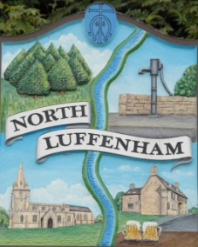
Councillors are summoned to the Parish Council (Trust) Extraordinary Meeting immediately following the Parish Council Meeting on Tuesday 30th July 2019 in the North Luffenham Community Centre
North Luffenham Parish Council

Agenda

The public may attend the meeting

46/19 Election of Chair
47/19 Election of Vice Chair
48/19 Apologies
49/19 Declarations of Interest
50/19 Finance Report – Clerk
  - To receive an update on the external review of Trust Account finances
  - To note the following contractual payments:
- £270.00 4 Counties Maintenance re June (3 Cuts)
- £214.29 Mow All June payment

51/19 Field Gardens Report - Cllr Cade
- Allotments update
- Woodland walk
- Update re meeting with RCC Forestry Officer to discuss tree maintenance plan
- To acknowledge support offered by the NL Scouts with regard to assisting with the maintenance.

52/19 Oval Report - Cllr Cade
- To receive and consider the request from Weston Power for an Easement for the laying of an HV and LV cable under the Oval, including their written agreement to cover the Trustee’s legal fees (Up to £1000 +vat), Surveyor’s Fee (£500+vat) plus pay a fee of £1000. To receive and consider the appointment of Chatterton’s as the Trust’s Legal representatives and Richardson’s as the Trust’s Surveying representatives
- Update re Trees

25/19 Date of next meeting: Monday 2nd September 2019 @ 7pm

John Willoughby,
Parish Clerk
18th July 2019

