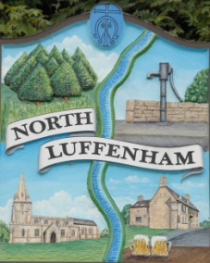
Councillors are summoned to the Parish Council (Trust) Extraordinary Meeting on Monday 19th August 2019 in the North Luffenham Community Centre @ 7.00pm
North Luffenham Parish Council

Agenda

The public may attend the meeting

54/19 Apologies
55/19 Declarations of Interest
56/19 Finance Report – Clerk
- To approve the transfer of £3000 from the money manager account to the current account to cover the invoice from George Walker Tree Care

57/19 Oval Report - Cllr Cade
- To fully consider the options with regard to the repair of the stone wall at the exit to Church Street

58/19 Date of next meeting: Monday 2nd September 2019 @ 7pm

John Willoughby,
Parish Clerk
12 Aug 2019

