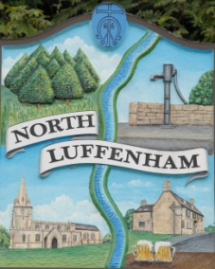
Councillors are summoned to the Parish Council (Trust) Meeting immediately following the Parish Council Meeting on Monday 2nd Sept 2019 in the North Luffenham Community Centre
North Luffenham Parish Council

Agenda

59/19 Apologies
60/19 Declarations of Interest
61/19 To approve and sign minutes of PC Trust meetings held on:
- 1st July 2019
- 30th July 2019 (Extraordinary meeting)
- 19th August 2019 (Extraordinary meeting)

62/19 Finance Report – Clerk
  - To receive a report from Cllr Sewell– Bank Reconciliation 18th August 2019
  - To consider and approve the finance report
  - To receive and consider the external report on the Trust Finances for 2018/19
  - To receive and approve the following payments
- £32.10; C Cade petrol and cement for goal posts
- £2966.88 (£2472.40 plus vat of £494.48) re removal of 2 trees plus fallen & broken branches)
  - To not the following contractual payments
- £214.29; Mow All July payment
- £270.00; 4 Counties July mowing (3 cuts)

63/19 Field Gardens Report - Cllr Cade
- Allotments update:
- Woodland Walk update

64/19 Oval Report - Cllr Cade

  - To receive and consider the request from NLPC for holding a bonfire night celebration on 5th Nov 2019 on the Oval Recreation Ground
  - To note that following agreement from the Trustee, for engaging Charles Richardson to undertake a report to the Trustee re the granting of an Easement under the Oval Recreation Ground at a cost of £500 plus vat (To be re-imbursed by Weston Power) and to receive an update on progress.
  - To receive an update on the Oval Trees and progress towards sorting out a replacement strategy
  - To receive an update with regard to the repair of the stonewall by the exit to Church Street. Quotes received:
- Stamford Stonecraft £760 plus VAT
- Abbey Stone and masonary £2,180 plusVAT
- Shaun Grey £850 (VAT not mentioned)

65/19 To report on progress re the setting up of a G Suite for Trust Business as agreed at the extraordinary meeting on 30th July 2019

66/19 Date of next meeting: To consider changing the date of the next meeting from Monday 21st October 2019 to Monday 28th October immediately following the PC meeting

John Willoughby,
Parish Clerk

