North Luffenham Parish Council

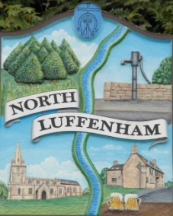
Notice is hereby given that there will be a meeting of
the Planning Committee of North Luffenham Parish Council on Wednesday, 21st August 2019 at 7.30 pm in the Community Centre.

Members of the public will have an opportunity to give their views.
Agenda
- Introduction
- Apologies
- Declarations of Interest
- Parking in Lyndon Road between The Fox Public House and Glebe Road (To include possible Site visit)
- Planning Applications - to discuss the following:
2019/0731/FUL PROPOSAL: Conversion of barn to create 2 No. dwelling houses. Sculthorpe House Pilton Road North Luffenham Rutland LE15 9PD

John Willoughby
Parish Clerk

