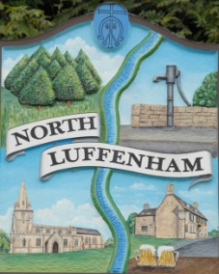
North Luffenham Parish Council

Minutes of the Parish Council Extraordinary Meeting held on Wednesday 18th Sept 2019 at North Luffenham Community Centre

Agenda

Present: Cllrs Cade, Burrows, Bishop, Anker and Mason.

Public: There were no members of the public present.

Apologies: Cllrs Smith and Sewell, County Cllrs Bool and Waller
Declarations of Interest; None declared
107/19 IT Working Group
Cllr Bishop gave the background as to whether NLPC should consider becoming part of the Digital Rutland LFFN Project. It was unanimously agreed that NLPC should support. An eligibility, Interest and Intention form was completed and sent to RCC.

108/19 Planning: Cllr Burrows
Reference: 2019/0879/FUL and 2019/0880/LBA
PROPOSAL: Application to regularise matters with regards to the property being used as two seperate dwellings. The Horse And Panniers 12A Church Street North Luffenham Rutland LE15 8JR LE15

It was decided to object on the grounds of appearance, listing and previous behaviour

109/19 Date of next meeting: Monday 28th October @, 7pm North Luffenham Community Centre.

Meeting Closed: 8.45 pm

