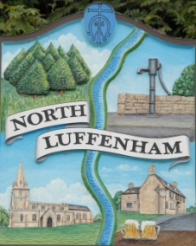
Councillors are summoned to the Parish Council (Trust) Meeting immediately following the Parish Council Meeting on Monday 28th Oct 2019 in the North Luffenham Community Centre
North Luffenham Parish Council

Agenda

67/19 Apologies
68/19 Declarations of Interest
69/19 To approve and sign minutes of PC Trust meeting held on:
- 2nd September 2019

70/19 Finance Report – Clerk
  - To receive a report from Cllr Mason– Bank Reconciliation 18th Oct 2019
  - To consider and approve the finance report
  - To receive and approve the following payments
- £378.85 (£315.71 plus £63.14 VAT)) George Walker Tree Care Ltd re removal of broken branches
- £368.63 (£307.19 plus £61.44 vat) RCC re tree inspection report
- £179.00; T Clifton re repair of Garden Bench
  - To not the following contractual payments
- £214.29; Mow All August payment
- £214.29; Mow All Sept Payment
- £270.00; 4 Counties August mowing (3 cuts)
- £450.00; 4 Counties September mowing (3 cuts) plus mowing of Woodland walk
e. To note VAT refund of £494.48.
f. To authorise the transfer of £2,000 from the deposit account to the cheques account to cover invoices received.

71/19 Field Gardens Report - Cllr Cade
- Allotments update:
- Woodland Walk update; To receive, consider and approve expenditure of up to £200 to purchase additional stakes, ties and other equipment to re-stake some of the trees

72/19 Oval Report - Cllr Cade

  - To note the update from Richardsons re Easement under the Oval Recreation Ground.
  - To receive an update on the Oval Trees and progress towards sorting out a replacement strategy
  - To receive, consider and approve spending £xxxx to carry out additional urgent work to remove 3 trees due to level of decay as per RCC report dated 6th September 2019
  - To receive an update with regard to the repair of the stonewall by the exit to Church Street.

73/19 To report on progress re the setting up of a G Suite for Trust Business as agreed at the extraordinary meeting on 30th July 2019

74/19 Date of next meeting: Monday 2 December immediately following the PC meeting

John Willoughby,
Parish Clerk

