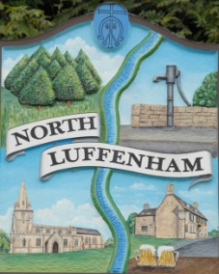
Councillors are summoned to the Parish Council (Trust) Meeting immediately following the Parish Council Meeting on Monday 2nd December 2019 in the North Luffenham Community Centre
North Luffenham Parish Council

Agenda

75/19 Apologies
76/19 Declarations of Interest
77/19 To approve and sign minutes of PC Trust meeting held on:
- 28th October 2019

78/19 Finance Report – Clerk
  - To receive a report from Cllr Burrows– Bank Reconciliation 18th November 2019
  - To consider and approve the finance report
  - To receive, consider and approve the Budget for 2020/2021 as submitted by the Finance Working Group.
  - To receive, consider and approve the grass cutting quotes received from Mow All (£224.29 pm an increase of £10pm) and 4 Counties Ground Maintenance (£120 per cut an increase of £30 per cut) for 2020
  - To note a VAT claim of £124.58
  - To receive and approve the following payments
- £562.79; Water Plus re water supply to the allotments

  - To not the following contractual payments
- £270.00; 4 Counties October Grass Cut (3)

79/19 Field Gardens Report - Cllr Cade
- Allotments update:
- Woodland Walk update:

80/19 Oval Report - Cllr Cade

  - To Consider the request from Western Power to re-route the HV Cable away from the main line of trees.
  - To receive an update on the Oval Trees and progress towards sorting out a replacement strategy

81/19 To report on progress re the setting up of a G Suite for Trust Business as agreed at the extraordinary meeting on 30th July 2019

82/19 To receive, consider and approve NLPC Trust meetings dates through to April 2021

83/19 Date of next meeting: Monday 20th January 2020 immediately following the PC meeting

John Willoughby,
Parish Clerk
26th November 2019

