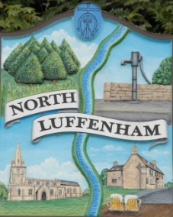
Dates of Meetings for NLPC / Trust meetings as approved
North Luffenham Parish Council

Dates from January 2020 – April 2021

All meetings are full Parish Council Meetings scheduled for Mondays unless stated otherwise below. The meetings usually begin at 7pm unless otherwise notified online and on printed Agendas and take place in the Community Centre:
- 6th January 2020 (Extraordinary meeting)
- 20th January 2020
- 2nd March 2020
- 20th April 2020 (Annual Parish Meeting)

- 18th May 2020 (Annual Parish Council Meeting)
- 6th July 2020
- 7th September 2020
- 19th October 2020
- 7th December 2020
- 25th January 2021
- 8th March 2021
- 19th April 2021 (Annual Parish Meeting)

