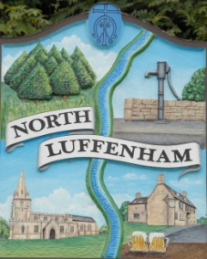
North Luffenham Parish Council

All Councillors are summoned to the Parish Council Meeting on Monday 20 January 2020 at 7pm which will take place in the North Luffenham Community Centre

Agenda

08/20 Apologies:
09/20 Declarations of Interest
10/20 Public Forum
11/20 To approve and sign minutes of the PC meetings:
- 2nd December 2019
- Extraordinary meeting 6th January 2020

12/20 Chairman’s Report.
- RCC Local Plan
- Neighbourhood Plan
- Resilience Planning

13/20 To receive an update of St George’s Barracks Development. – Cllr Smith/Anker

14/20 Correspondence – Clerk
- 3 emails and 1 letter re starling issues in Ancaster Way
- 1 email re dog fouling

15/20 Finance Report – Clerk

  - To receive a report from Cllr Mason – Bank Reconciliation 1st Jan 2020
  - To consider and approve Finance Report

16/20 Planning: Cllr Burrows
Decsion Notice; Refusal: Application Number: 2019/0878/PTA
PROPOSAL: 2 no. Corsican Pine trees: T1 - cutback/reduce lower branches that overhang the boundary with 24 Kings Rd. T3 - remove lower branch over hanging garage.
LOCATION: 22 Kings Road North Luffenham Rutland LE15 8JH

17/20 Highways: To report to RCC re potholes in Digby drive and Lyndon Road

18/20 To receive and consider the report from the Community Centre Working Group

19/20 To receive an update re plans with regard to VE Day Celebrations in May 2020

20/20 To receive, consider and approve the purchase of further play equipment for the Oval Recreation Ground, using Section 106 monies.

21/20 Date of next meeting: 2nd March 2020 @ 7.00pm, North Luffenham Community Centre

John Willoughby
Parish Clerk
14th January 2020

