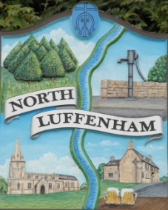
Councillors are summoned to the Parish Council (Trust) Meeting immediately following the Parish Council Meeting on Monday 20th Jan 2020 in the North Luffenham Community Centre
North Luffenham Parish Council

Agenda

01/20 Apologies:
02/20 Declarations of Interest
03/20 To approve and sign minutes of PC Trust meeting held on:
- 2nd Dec 2019

04/20 Finance Report – Clerk
  - To receive a report from Cllr Mason– Bank Reconciliation 18th December 2019
  - To consider and approve the finance report
  - To receive and approve the following payments
- £121.30; Water Plus re water supply to the allotments
- £160.47; Posts and ties for trees along Woodland Walk
- £326.52; J Coles Nurseries Re purchase of 6 replacement trees for the Oval. (£272.10 plus vat £54.42)

05/20 Field Gardens Report - Cllr Cade
- Allotments update:
- Renewal Payments
- Clearance of vacated allotment
- Woodland Walk update:

06/20 Oval Report - Cllr Cade

  - To Consider the request from Western Power to re-route the HV Cable away from the main line of trees.
  - To receive an update on the Oval Trees and progress towards sorting out a replacement strategy

07/20 To report on progress re the setting up of a G Suite for Trust Business as agreed at the extraordinary meeting on 30th July 2019

08/20 Date of next meeting: Monday 2nd March 2020 immediately following the PC meeting

John Willoughby,
Parish Clerk
14th Jan 2020

