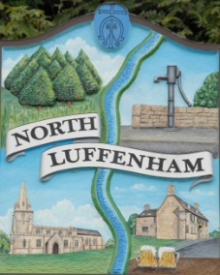
North Luffenham Parish Council

All Councillors are summoned to the Parish Council (Trust) Extraordinary Meeting on Monday 23rd March 2020 immediately following the Parish Council Meeting which will take place in the North Luffenham Community Centre

Agenda

18/20 Apologies:
19/20 Declarations of Interest
20/20 To receive, consider and approve actions that can be delegated and to whom as a consequence of the COVID-19 pandemic

21/20 Finance:
- To note the following contractual payments:
- £164.95; Waterplus re allotments

22/20 Oval report:
- To note that the 3 trees have been felled in accordance with the 2019 tree report
- To receive and consider the annual play equipment report and approve the cost of £1012.00 plus vat to replace the worn items as identified in that report

23/20 Allotment report
- To note that all allotment rents have now been received

24/20 Date of next meeting:
- Annual Parish Meeting, Monday 20th April @ 7.00pm, North Luffenham Community Centre
- Annual Parish Council Meeting, Monday 18th May @ 7.00pm, North Luffenham Community Centre

John Willoughby
Parish Clerk
17th March 2020

