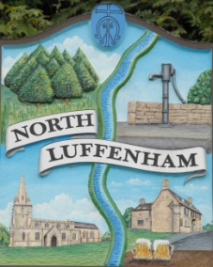
Councillors are summoned to the Parish Council (Trust) Meeting (virtual) immediately following the Parish Council Meeting on Tuesday 14th April
North Luffenham Parish Council

Agenda

18/20 Apologies:
19/20 Declarations of Interest
20/20 To approve and sign minutes of PC Trust meeting held on:
- 2nd March 2020

21/20 Finance Report – Clerk
  - To consider and approve the finance report for the year ending 31st March 2020
  - To note the following contractual payments:
- £164.95; Waterplus re allotment water supply
- £105.00; 4 Counties re March cut of Oval
- £3561.86; George Walker Tree Care re removal of 3 trees. (£2968.22 plus vat of £593.64)

22/20 Field Gardens Report - Cllr Cade
- Allotments update:
- To note that all renewal payments have been paid.
- Clearance of vacated allotment 3f
- Woodland Walk update:

23/20 Oval Report - Cllr Cade

  - To Consider the request from Western Power to re-route the HV Cable away from the main line of trees
  - To note that the 3 trees have been felled in line with the 2019 tree report

24/20 To report on progress re the setting up of a G Suite for Trust Business as agreed at the extraordinary meeting on 30th July 2019

25/20 To receive and consider the timing and frequency of future Parish Council Trust meetings.

John Willoughby,
Parish Clerk
6th April 2020

