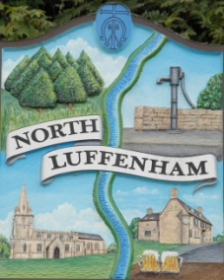
All Councillors are summoned to the Parish Council (Trust) Annual Meeting (virtual) immediately following the Parish Council Meeting on Monday, 18th May 2020.
North Luffenham Parish Council

Agenda

26/20 Election of Chair, Vice-Chair
27/20 Apologies:
28/20 Declarations of Interest
29/30 To review and confirm Committees & Working Groups for 2017/18
- Oval/Field Working Group – currently Cllrs Cade, Mason, Burrows and Smith

30/20 To approve and sign Minutes as follows:
- Parish Council (Trust) meeting of 14th April 2020 (virtual)

31/20 Finance Report – Clerk
- to receive consider and approve Finance Report
- To note the following contractual payments
- £224.29 Mow All re grass cutting
- To receive consider and approve the following payments:
- £54.99 Grass seed and tree ties re woodland walk

32/20 Field Gardens Report - Cllr Cade
- Allotments
- Woodland Walk: To receive, consider and approve spending up to £250 on the cutting the grass on the woodland walk

33/20 Oval Report - Cllr Cade
- Play Equipment Report
- Easement Request from Western Power

34/20 Date of next meeting: Monday, 6th July 2020, immediately following the NLPC meeting

John Willoughby
Parish Clerk
11th May 2020

