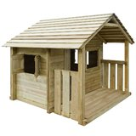3 Window Wood Playhouse
See More by Freeport Park
Brand Rating
£669.99

