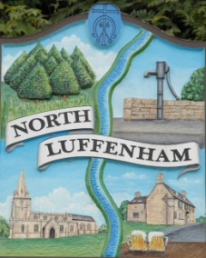
All Councillors are summoned to the Parish Council (Trust) Annual Meeting (virtual) immediately following the Parish Council Meeting on Monday, 6th July 2020.
North Luffenham Parish Council

Agenda

35/20 Apologies:
36/20 Declarations of Interest
37/20 To approve and sign Minutes as follows: Annual Parish Council (Trust) meeting of 18th May 2020 (virtual)

38/20 Finance Report – Clerk
- To receive a report from Cllr Burrows – Bank Reconciliation
- To receive, consider and approve Finance Report
- To note the receipt of VAT of £593.64
- To note the following contractual payments:
- £315.00 4 Counties re Grass cut April
- £495.00 4 Counties re Grass cut May
- £224.29 Mow All re May Cut
- £150.00 A Bates re clearance of overgrown area of brambles, behind Geoff Sewell Close.
- £72.86 Waterplus re Allotment water supply

39/20 Field Gardens Report - Cllr Cade
- Allotments

40/20 Oval Report - Cllr Cade
- To receive, consider and agree the new proposal from Western Power in connection with the electricity sub-station (Cllr Smith)
- To receive and consider the assessment of a further 22 trees on the Oval by Stuart Kidd (RCC Forestry Officer) at a cost of £244.35 plus VAT. This is in accordance with the full assessment carried out in 2017.
- To consider and agree the arrangements for allowing the use of the playground equipment following the easing of lockdown so we meet Government guidelines

41/20 To receive, consider and agree to move the September meeting from the 7th September to Monday 28th September 2020

42/20 Date of next meeting: Monday 10th August, immediately following the NLPC meeting (Virtual)

John Willoughby
Parish Clerk
30th July 2020

