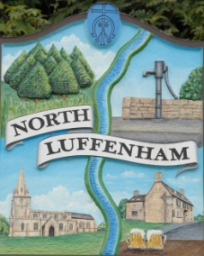
North Luffenham Parish Council

All Councillors are summoned to the North Luffenham Parish Council Extraordinary Meeting (virtual) on Wednesday 12th August @ 7.30pm

Agenda

This will be a closed meeting

111/20 Apologies:
112/20 Declarations of Interest
113/20 Co-option of two new councillors on to North Luffenham Parish Council. To receive, consider and then vote on the candidates who have expressed an interest in being co-opted on to the Parish Council. All prospective candidates having informally met with Cllr’s Smith and Canham

114/20 Date of next meeting (virtual); Monday 28th September @ 7.30pm

John Willoughby
Parish Clerk
6th August 2020

