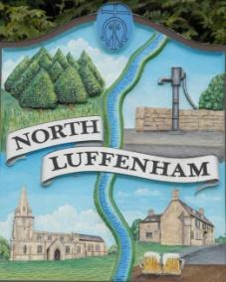
All Councillors are summoned to the Parish Council Meeting (virtual) on Monday, 10th August at 7.30pm
North Luffenham Parish Council

Agenda

97/20 Apologies
98/20 Declarations of Interest
99/20 Public Forum

100/20 To approve and sign Minutes as follows:
Annual Parish Council meeting of 6th July 2020 (virtual)

101/20 Chairman’s Report
- RCC Local Plan
- Co-option of Councillors
- Gate from Oval on to Church Street
- SGB Development Fighting Fund.

102/20 Correspondence – Clerk
- RCC – Weekly confidential Covid-19 briefings
- RCC – Email from Stuart Kidd (forestry officer) re 4 dead trees on approach to School.

103/20 Finance Report – Clerk
- To receive a report from Cllr Burrows – Bank Reconciliation
- To receive consider and approve the Finance Report
- To receive, consider and approve the following payments
- £115.95 re C Cade sanitiser equipment
- £759.99 re Wayfair Playhouse
- £46.80 re Stationary Clerk

104/20 Planning - Cllr Burrows
Reference: 2020/0805/FUL
PROPOSAL: Single storey rear extension.
20 Kings Road North Luffenham Rutland LE15 8JH

Reference: 2020/0760/FUL
PROPOSAL: West Wing Side Extension and First Floor Extension with Dormer
Windows. Alterations to side passage due to the removal of the existing garage.
Lambley Cottage Lyndon Road North Luffenham Rutland LE15 8JZ

105/20 To receive and consider a report concerning the ‘Fight4Rutland’ campaign and whether NLPC should contribute funds to this campaign by an increase in precept.

106/20 To receive and consider the report from the Community Centre Working Group:

107/20 To receive and consider the report from the Neighbourhood Plan Steering Committee:

108/20 To consider and discuss the proposal to run Bonfire Night 2020

109/20 To consider a date for an informal strategy meeting.

110/20 Date of next Parish Council meeting, Monday 28th September 7.30pm (virtual)

John Willoughby
Parish Clerk
4th August 2020

