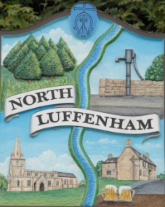
All Councillors are summoned to the Parish Council (Trust) Meeting (virtual) immediately following the Parish Council Meeting on Monday, 10th August 2020.
North Luffenham Parish Council

Agenda

43/20 Apologies:
44/20 Declarations of Interest
45/20 To approve and sign Minutes as follows: Parish Council (Trust) meeting 6th July 2020 (virtual)

46/20 Finance Report – Clerk
- To receive a report from Cllr Burrows – Bank Reconciliation
- To receive, consider and approve Finance Report
- To receive, consider and approve the following payment:
£108. National Allotment Society fee for 2020
- To note the following contractual payments:
- £224.29 Mow All re June Cut
- £315.00 4 Counties re June Cut
- £224.29 Mow All re July Cut

47/20 Field Gardens Report - Cllr Cade
- Allotments
- Woodland Walk; to receive and consider making the woodland walk a circular route as per the attached plan

48/20 Oval Report - Cllr Cade

49/20 Date of next meeting: Monday 28th September, immediately following the NLPC meeting (Virtual)

John Willoughby
Parish Clerk
4th August 2020

