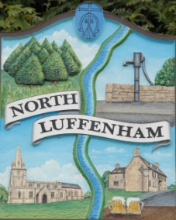
All Councillors are summoned to the Parish Council (Trust) Meeting (virtual) immediately following the Parish Council Meeting on Monday, 28th September 2020.
North Luffenham Parish Council

Agenda

50/20 Apologies:
51/20 Declarations of Interest
52/20 To approve and sign Minutes as follows: Parish Council (Trust) meeting 10th August (virtual)

53/20 Finance Report – Clerk
- To receive a report from Cllr Burrows – Bank Reconciliation
- To receive, consider and approve Finance Report
- To note the following contractual payments:
- £224.29 Mow All re August Cut
- £315.00 4 Counties re July Cut
- £101.22 Waterplus re Allotments

54/20 Field Gardens Report - Cllr Cade
- Allotments
- Woodland Walk; to receive and consider an updated plan for the woodland walk circular route

55/20 Oval Report - Cllr Cade
- Report on the Trees by Stuart Kidd, RCC Forestry Officer

49/20 Date of next meeting: Monday 19th October, immediately following the NLPC meeting (Virtual)

John Willoughby
Parish Clerk
21st September 2020

