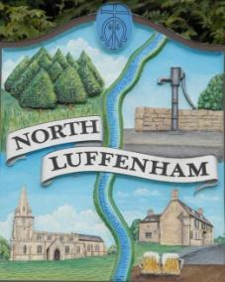
North Luffenham Parish Council

All Councillors are summoned to the North Luffenham Parish Council Extraordinary Meeting (virtual) on Monday 2nd November @ 7.30pm

Agenda

The public may attend the meeting but there will be no public forum

141/20 Apologies:
142/20 Declarations of Interest
143/20 To receive, consider and approve the NLPC response to the proposed RCC Local Plan (Regulation 19)

144/20 Neighbourhood Plan: To receive an update on its development including the Community Engagement event (virtual) held on 22nd October 2020 and future presentations.

145/20 Welland Rivers Trust: To receive an update following the presentation on 19th October PC meeting

146/20 Planning Cllr Burrows

Reference: 2020/1062/FUL
PROPOSAL: Application to regularise matters with regards the property being used as two separate dwellings.
The Horse and Panniers 12A Church Street North Luffenham Rutland LE15 8JR
An application for the above proposal has been received by the Local Planning Authority and you are invited to submit your comments by 4 November 2020.
The Horse and Panniers 12A Church Street North Luffenham Rutland LE15 8JR
Reference: 2020/1063/LBA
PROPOSAL: Application to regularise matters with regards the property being used as two separate dwellings.
The Horse and Panniers 12A Church Street North Luffenham Rutland LE15 8JR
An application for the above proposal has been received by the Local Planning Authority and you are invited to submit your comments by 4 November 2020.
The Horse and Panniers 12A Church Street North Luffenham Rutland LE15 8JR

147/20 Date of next meeting (virtual); Monday 7th December @ 7.30pm

John Willoughby
Parish Clerk
27th October 2020

