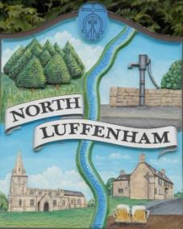
North Luffenham Parish Council

All Councillors are summoned to the North Luffenham Parish Council Extraordinary Meeting (virtual) on Monday 2nd November @ 7.30pm

Agenda

The public may attend the meeting but there will be no public forum

141/20 Apologies:
142/20 Declarations of Interest
143/20 To receive, consider and approve the NLPC response to the proposed RCC Local Plan (Regulation 19)

144/20 Neighbourhood Plan: To receive an update on its development including the Community Engagement event (virtual) held on 22nd October 2020 and future presentations.

145/20 Welland Rivers Trust: To receive an update following the presentation on 19th October PC meeting

146/20 Date of next meeting (virtual); Monday 7th December @ 7.30pm

John Willoughby
Parish Clerk
27th October 2020

